Rohan Nyati

500075940

R177219148

Batch-5 (AI & Ml)

**Lab File**

# Experiment 1

Anaconda & Spyder Installation for windows

1. Click on the link below to open the download page

https://www.anaconda.com/download/#windows



1. Click on the Download button and check for the compatibility of your system. Then, it will start downloading.

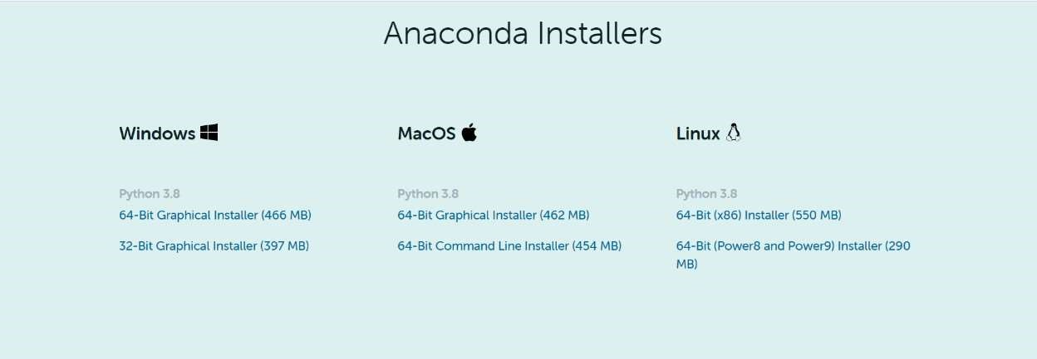

1. Double click the installer to launch.
2. Click on Next.



1. Read the license agreement and click on “I Agree”.



1. Select installation type “Just Me” unless you’re installing it for all users (which require Windows Administrator privileges) and click on Next.

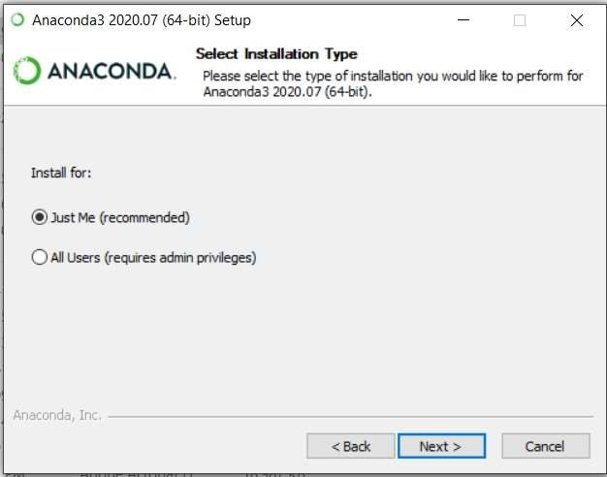

1. Select a destination folder to install Anaconda and click the Next button.



1. Choose whether to add Anaconda to your PATH environment variable. We recommend NOT adding Anaconda to the PATH environment variable, since this can interfere with other softwares. Instead, use Anaconda software by opening

Anaconda Navigator or the Anaconda Prompt from the Start Menu

Choose whether to register Anaconda as your default Python. Unless you plan to install and run multiple versions of Anaconda or multiple versions of Python, accept the default version and leave this box checked.

1. Click the Install button.

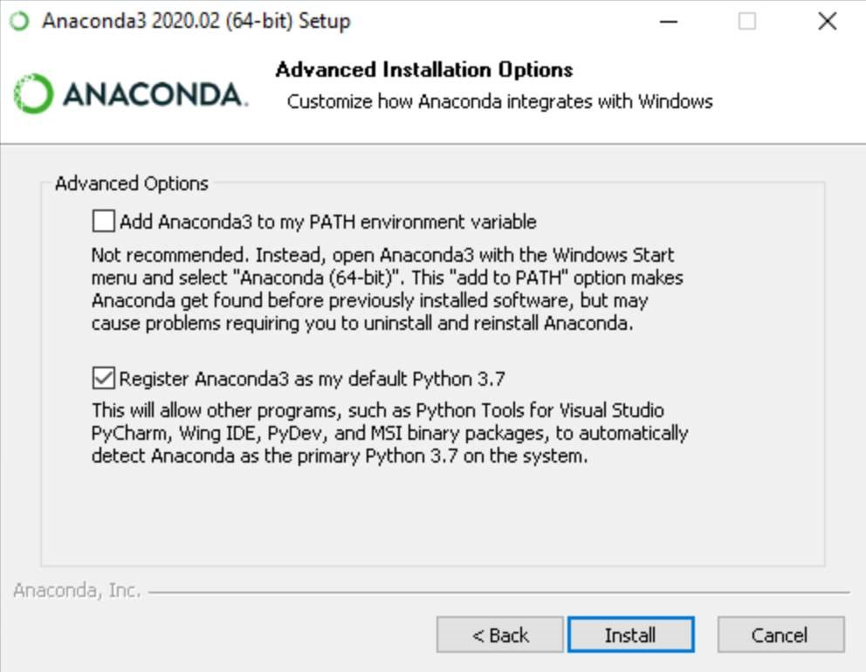

If you want to watch the packages Anaconda is installing, click on Show Details.

1. Click on the Next button.



1. And then click the Finish button.



1. After a successful installation you will see the “Thanks for installing Anaconda” dialog box.

13.Open Anaconda navigator.

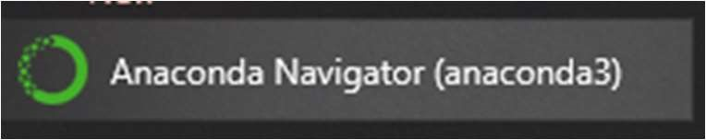

14. This screen will pop up.

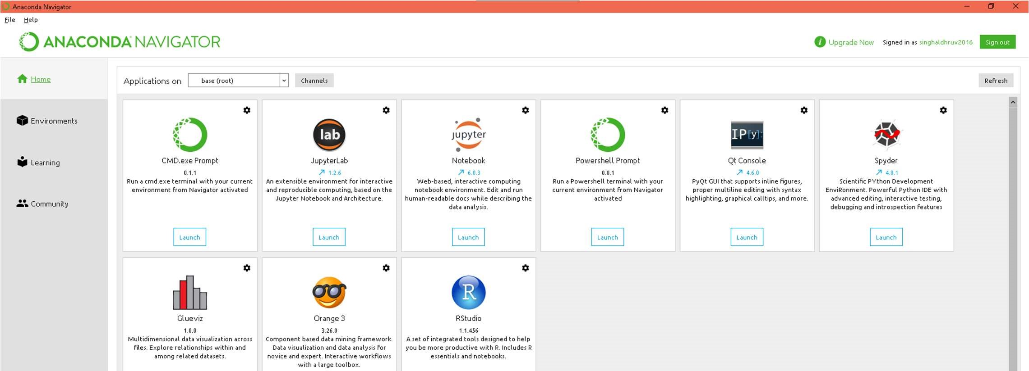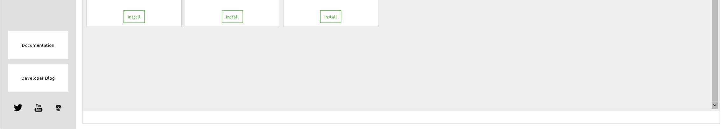

15.Go to “Environments “ from Left Side panel.

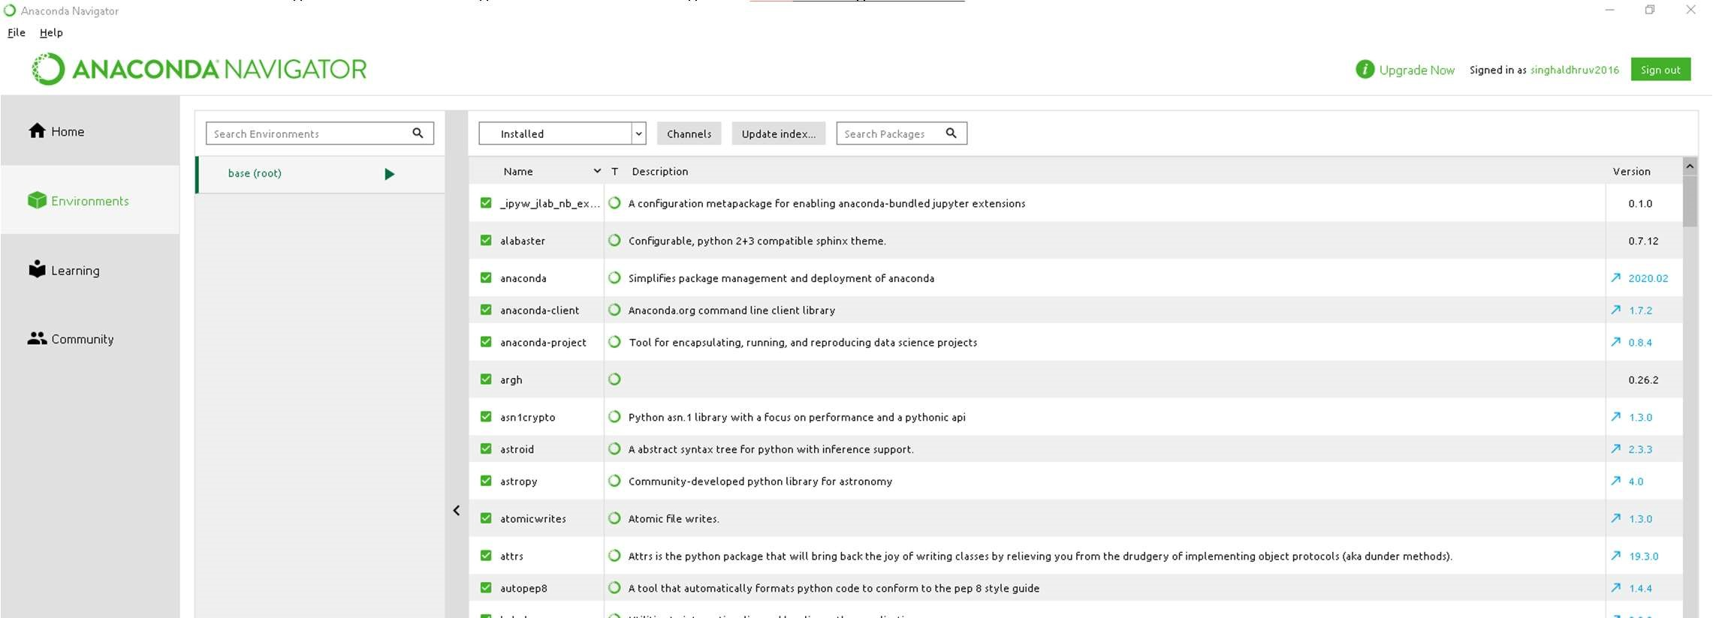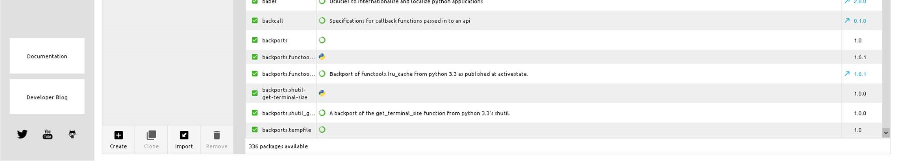

1. From Bottom Left click “Create” and choose version and name of the environment.

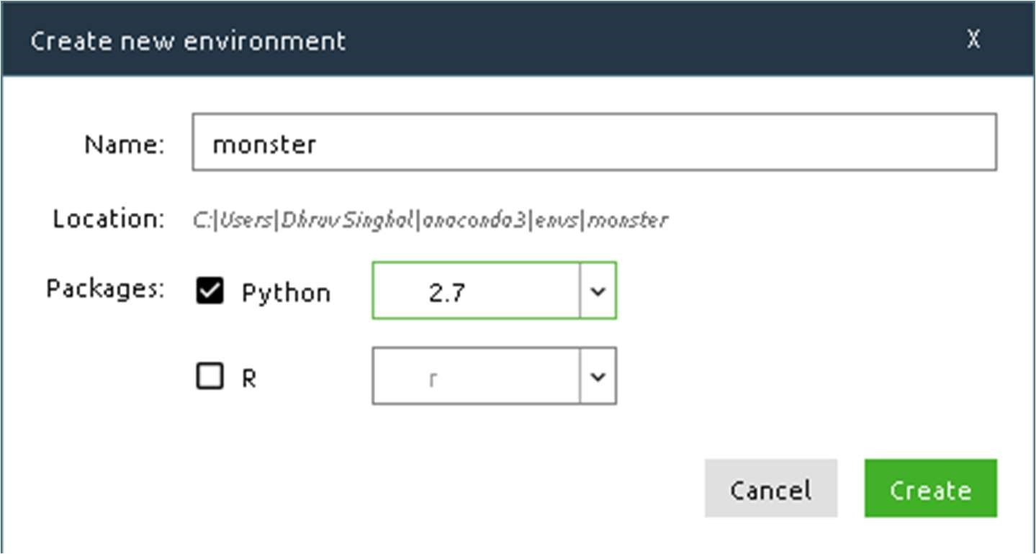

1. Create environment.

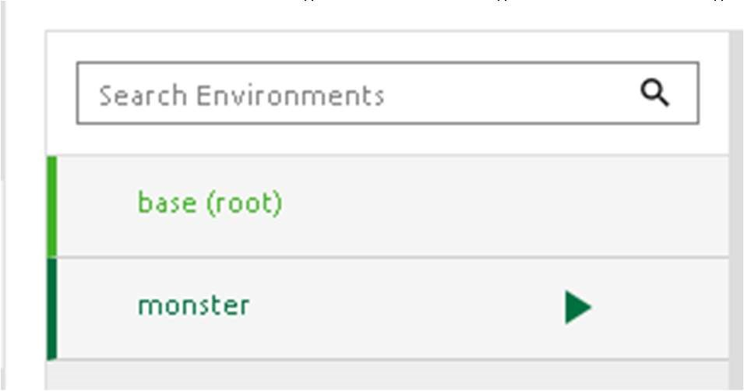

1. Activate Environment from Anaconda Prompt and Launch Spyder(After installing From Anaconda Navigator)

Spyder:

Spyder, the Scientific Python Development Environment, is a free integrated development environment (IDE) that is included with Anaconda.

It includes:

* + Editing
  + Interactive testing
  + Debugging
  + Introspection features

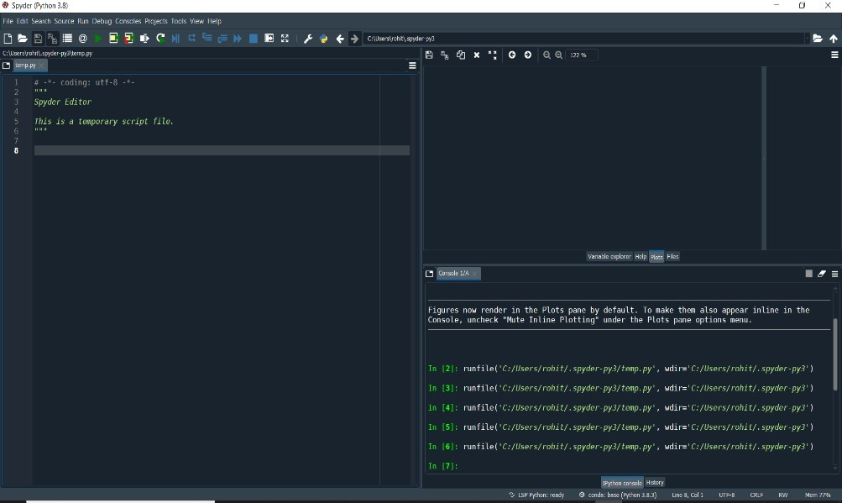

Editor

Console

Variable

/help /file

/plot space

Steps for Spyder setup and run a test code:

1. In Window search box, type Spyder and press Enter. 2. Spyder IDE opened and you can see a total of 3 area:

* + 1. Editor
    2. Console
    3. Variable/help/file/plot space

* + 1. Let’s write a test code in the Editor and run the code by clicking on Run button.

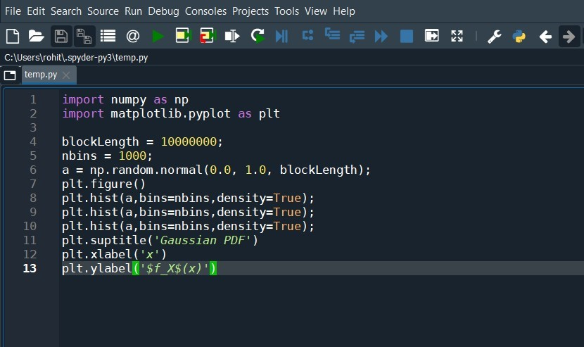

* + 1. You can see the variable, plot, files on right side of IDE by clicking appropriate tabs as highlighted with Red color below.

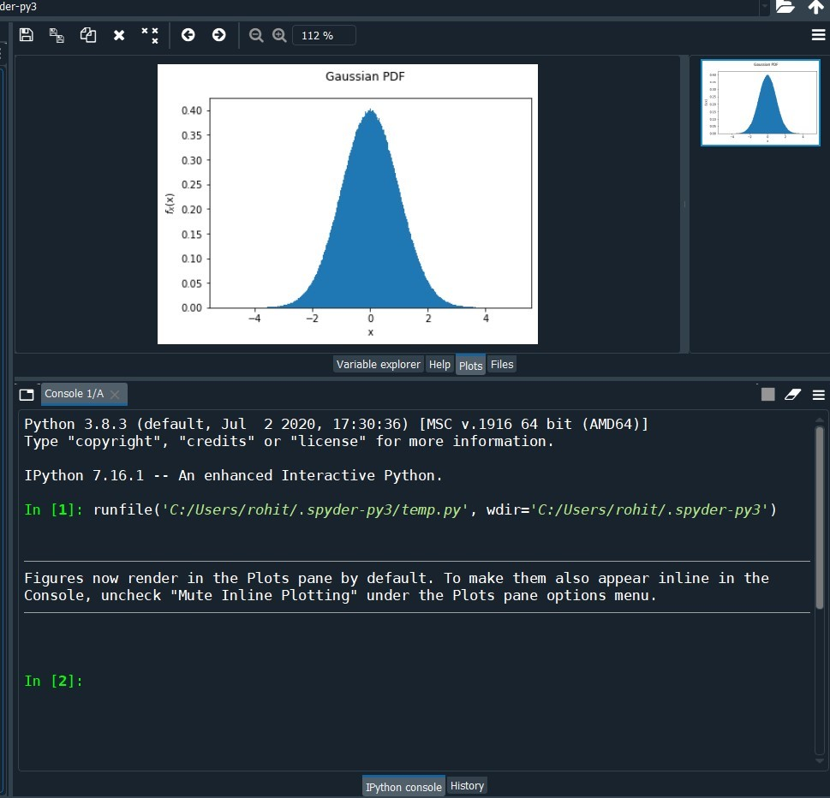

* + 1. As a whole Spyder screen looks like as below.

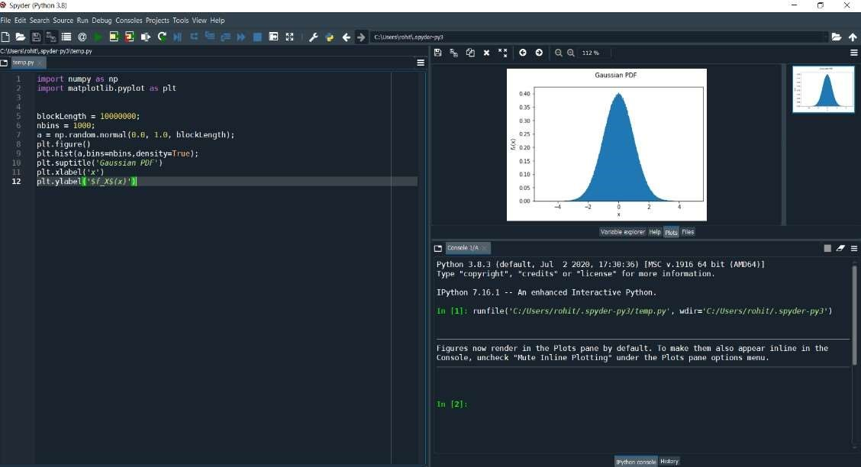

# Experiment 2

Pandas

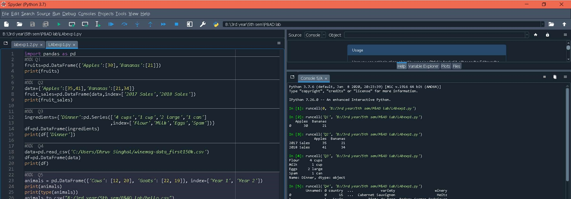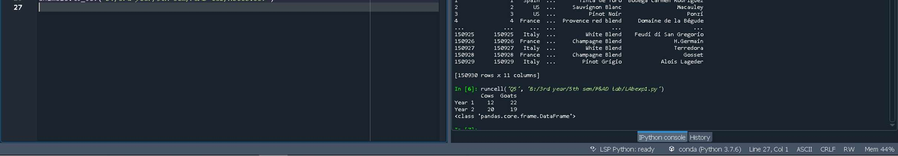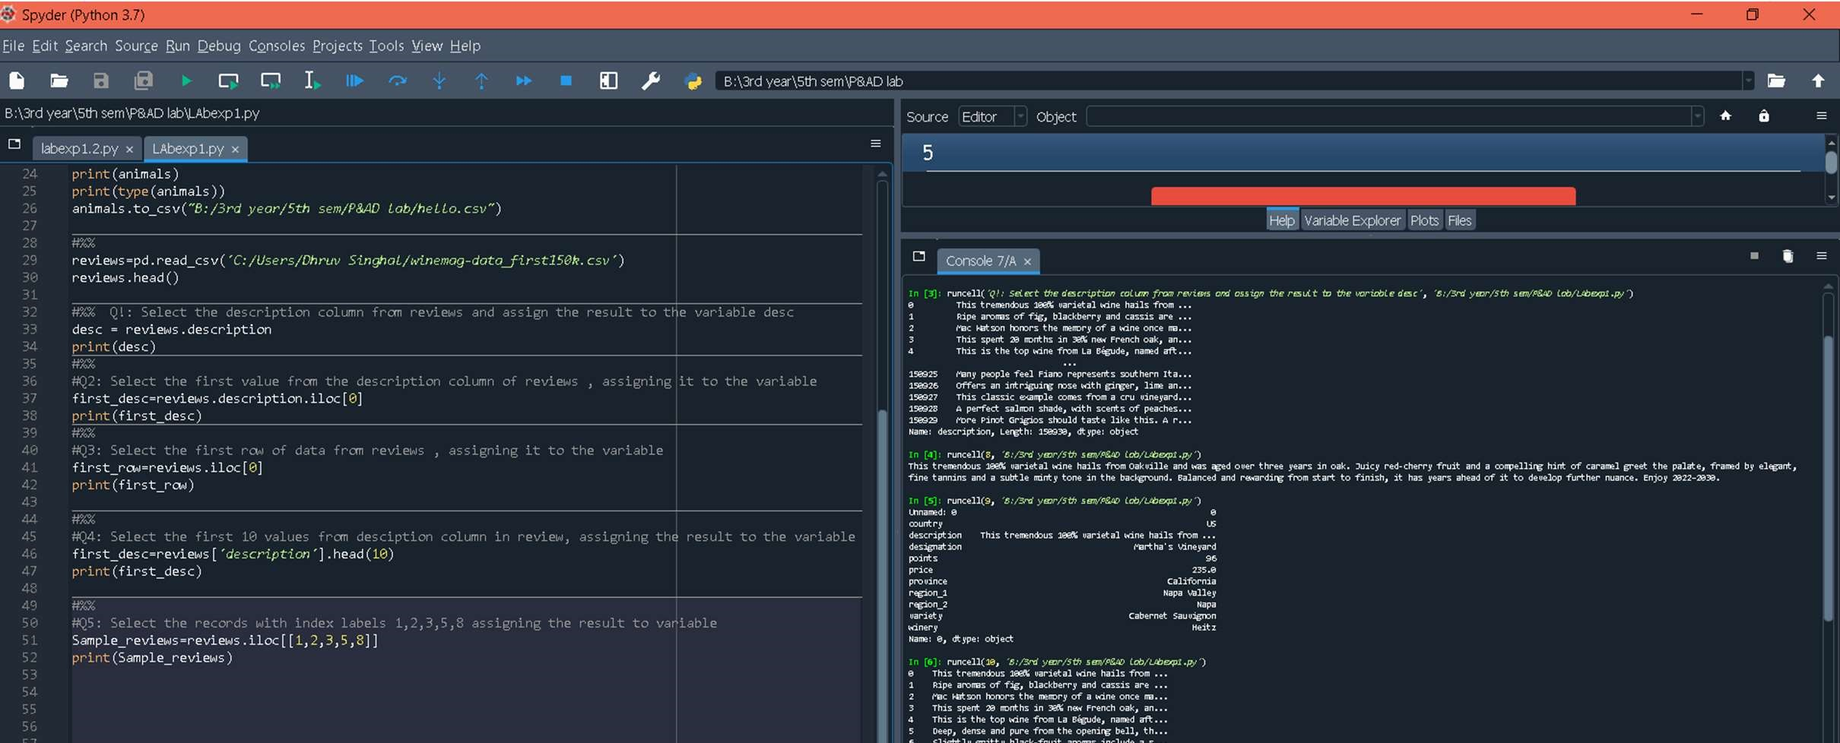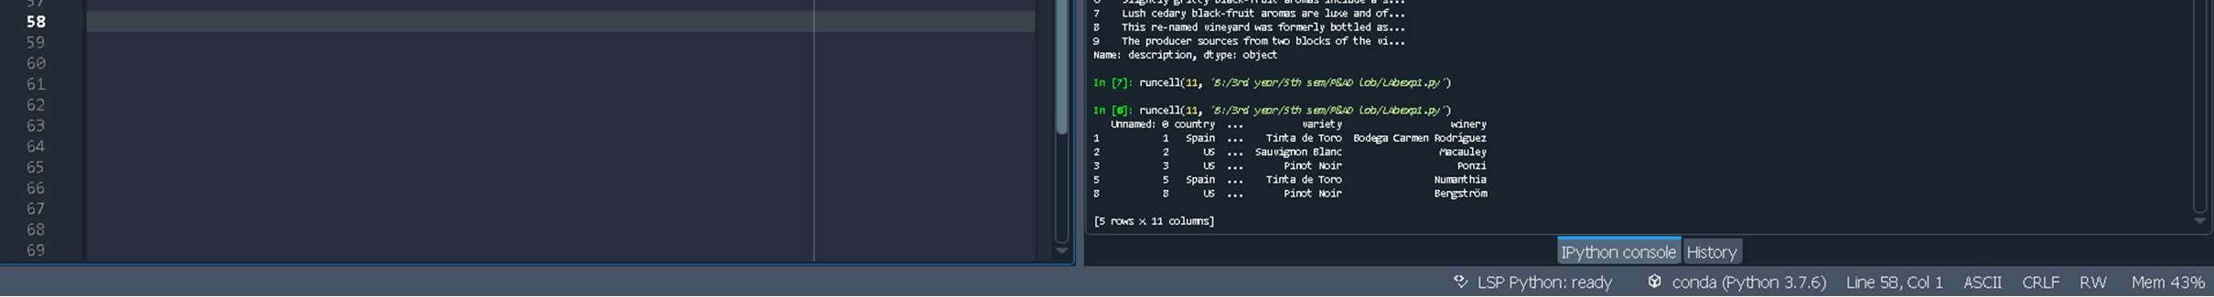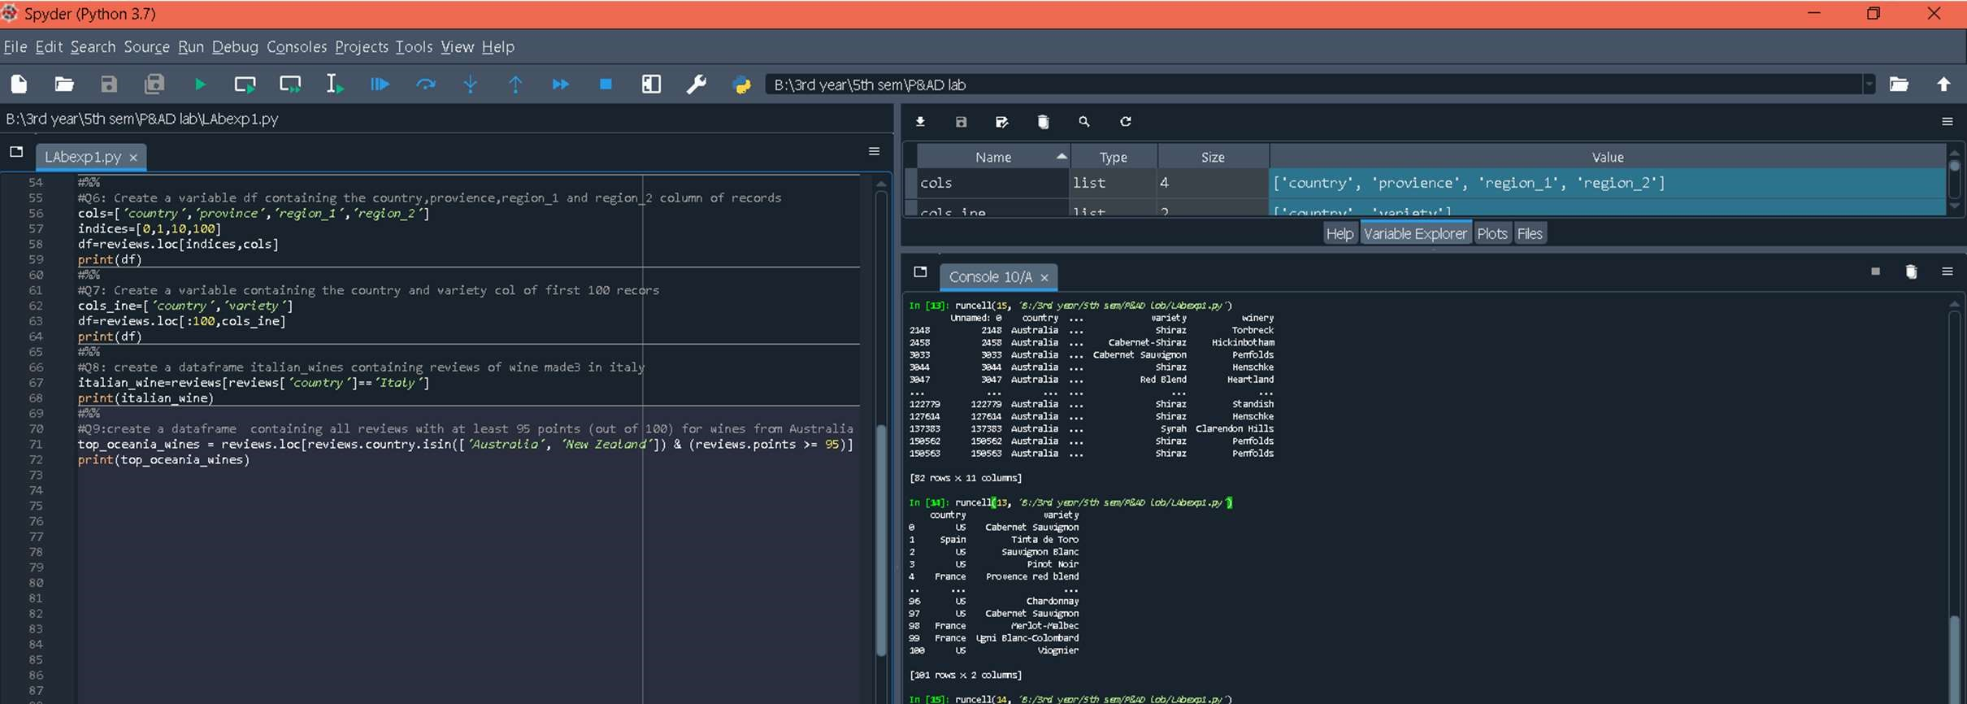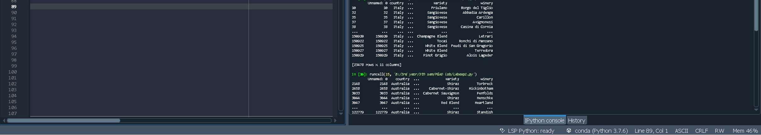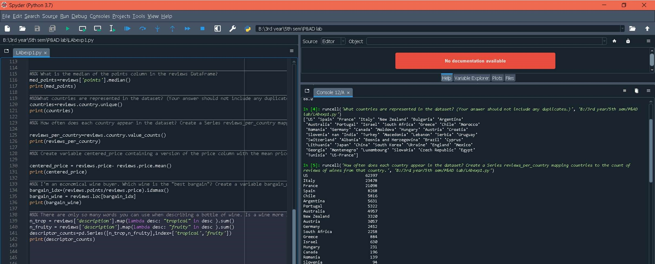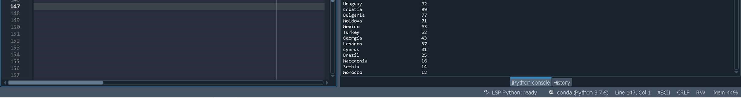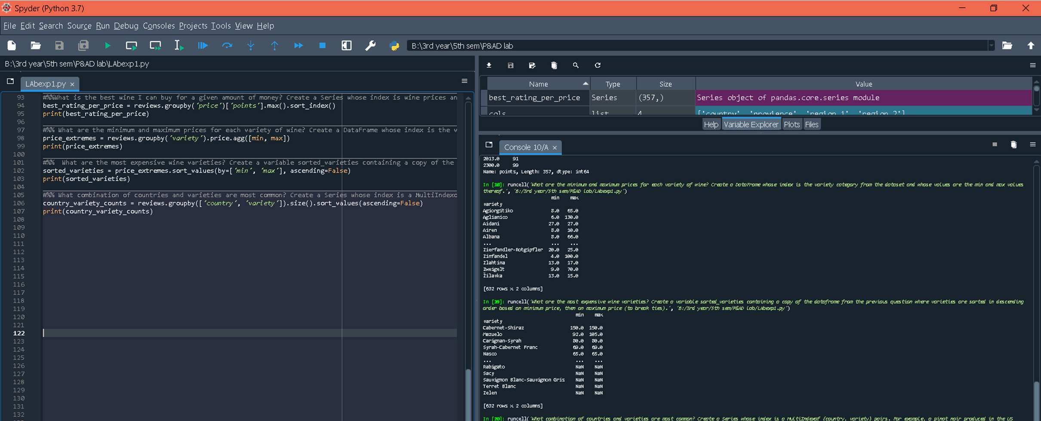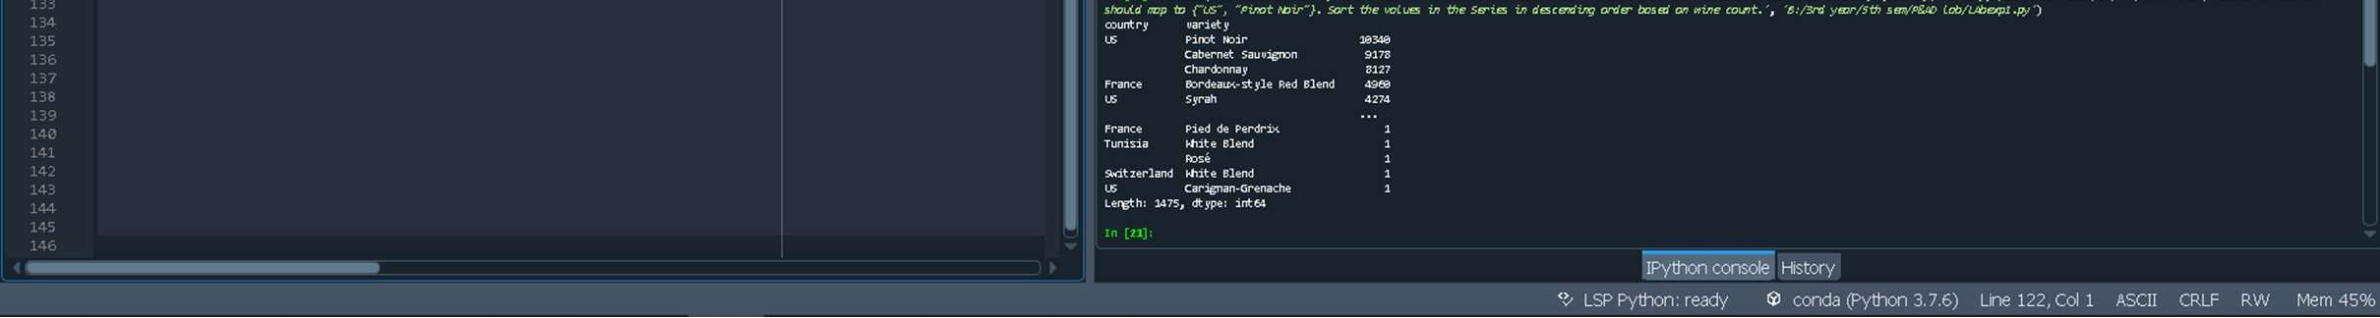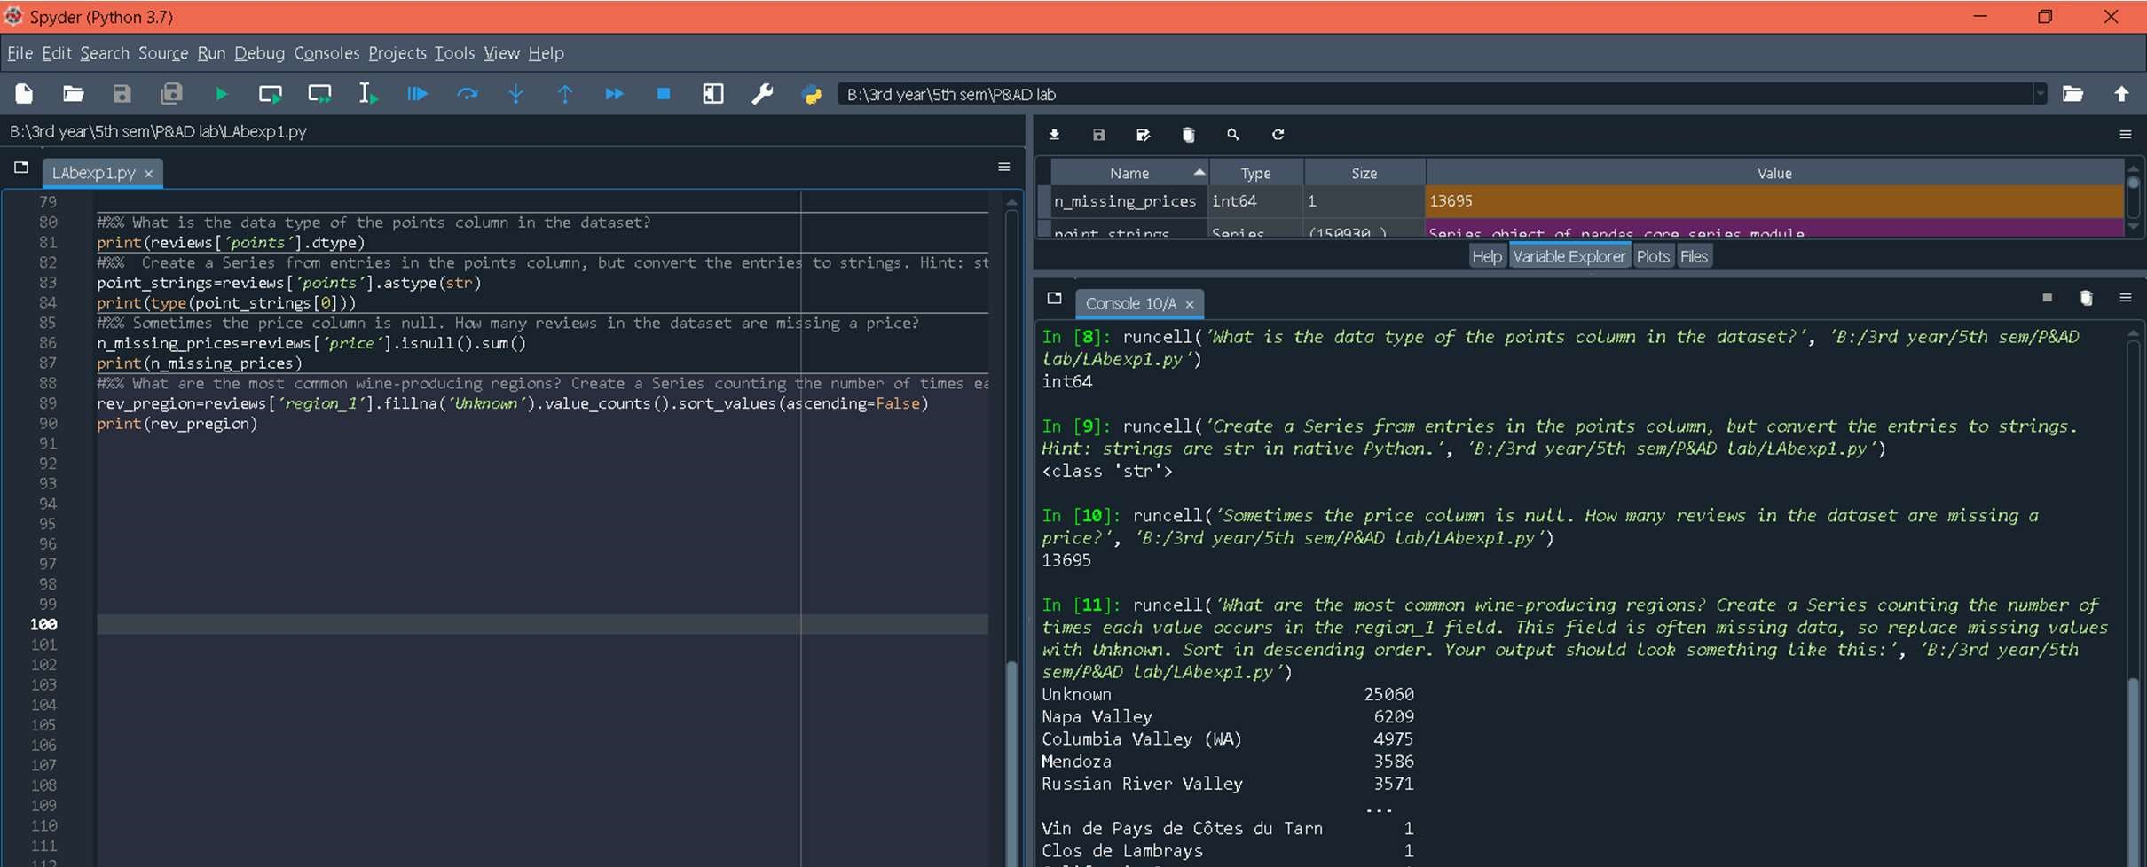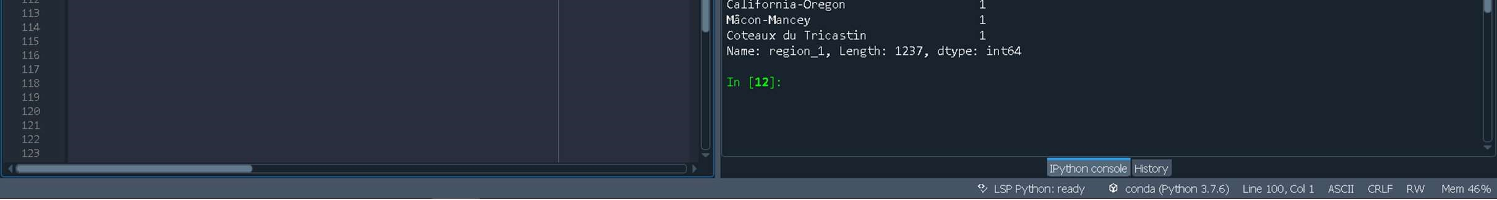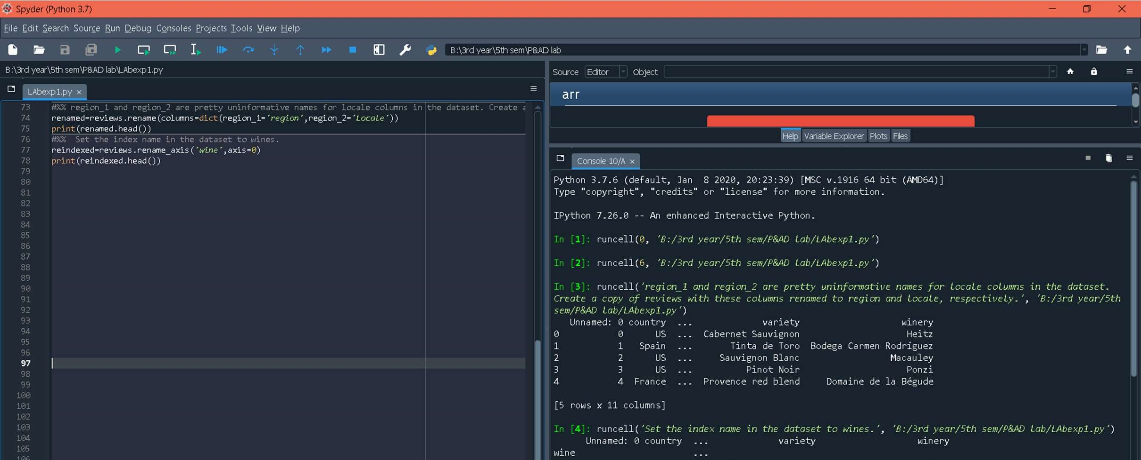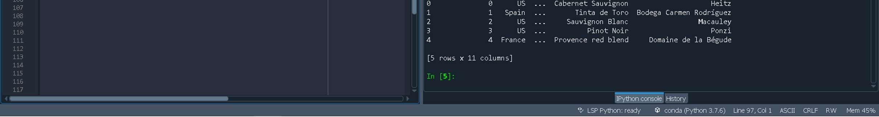

NumPy

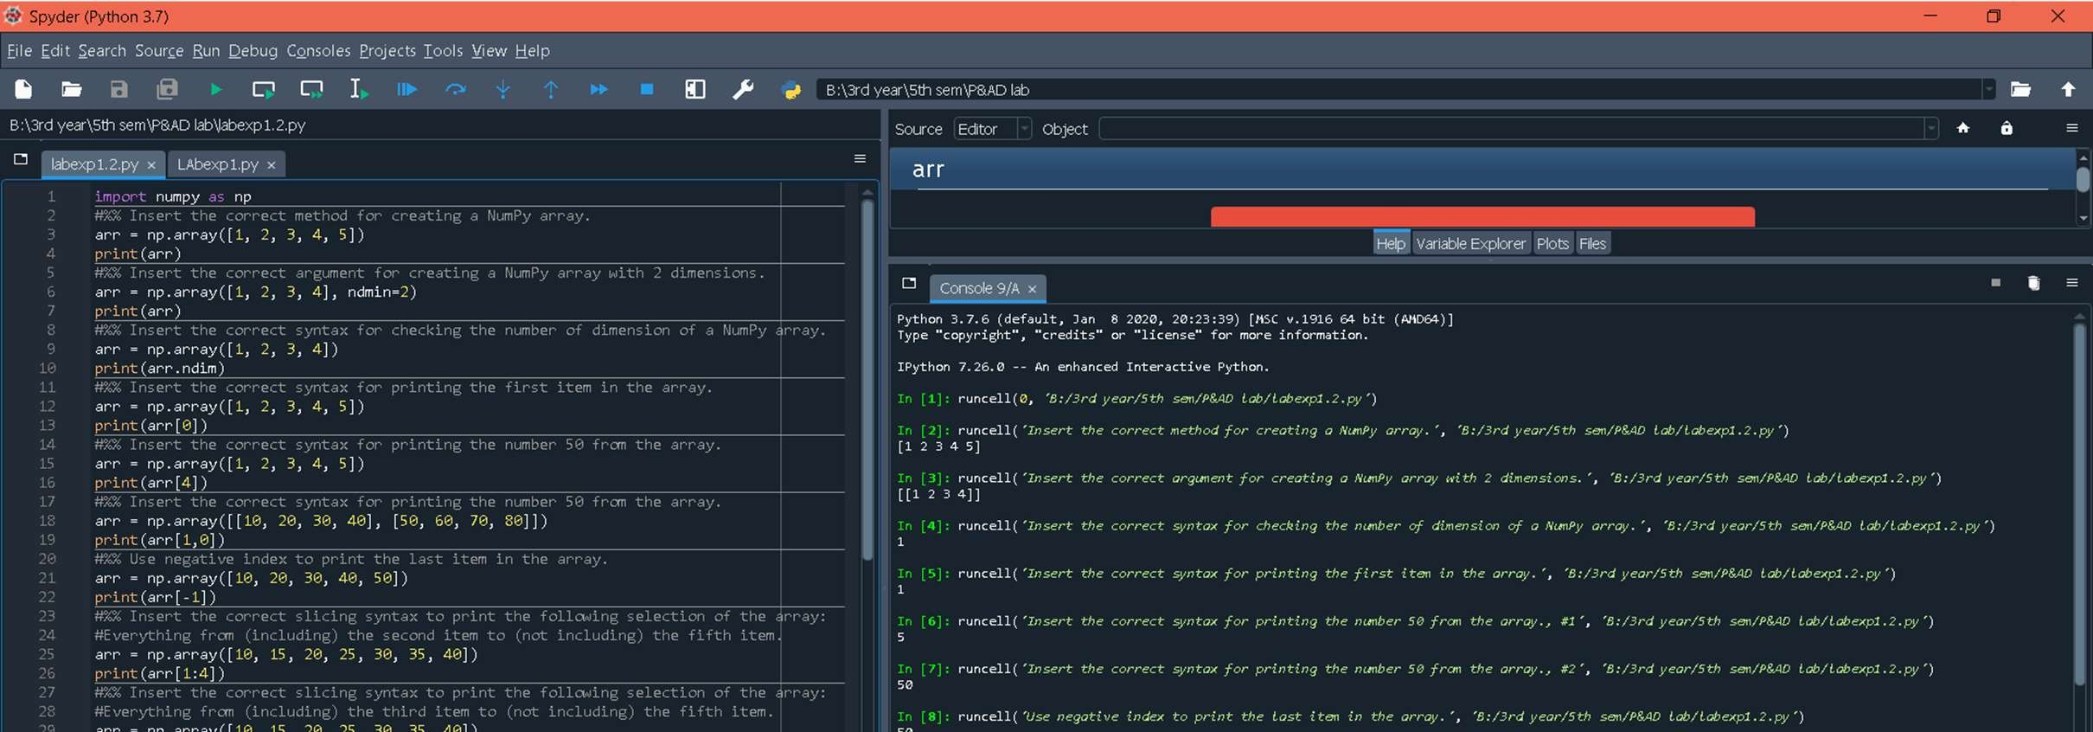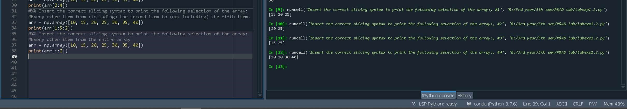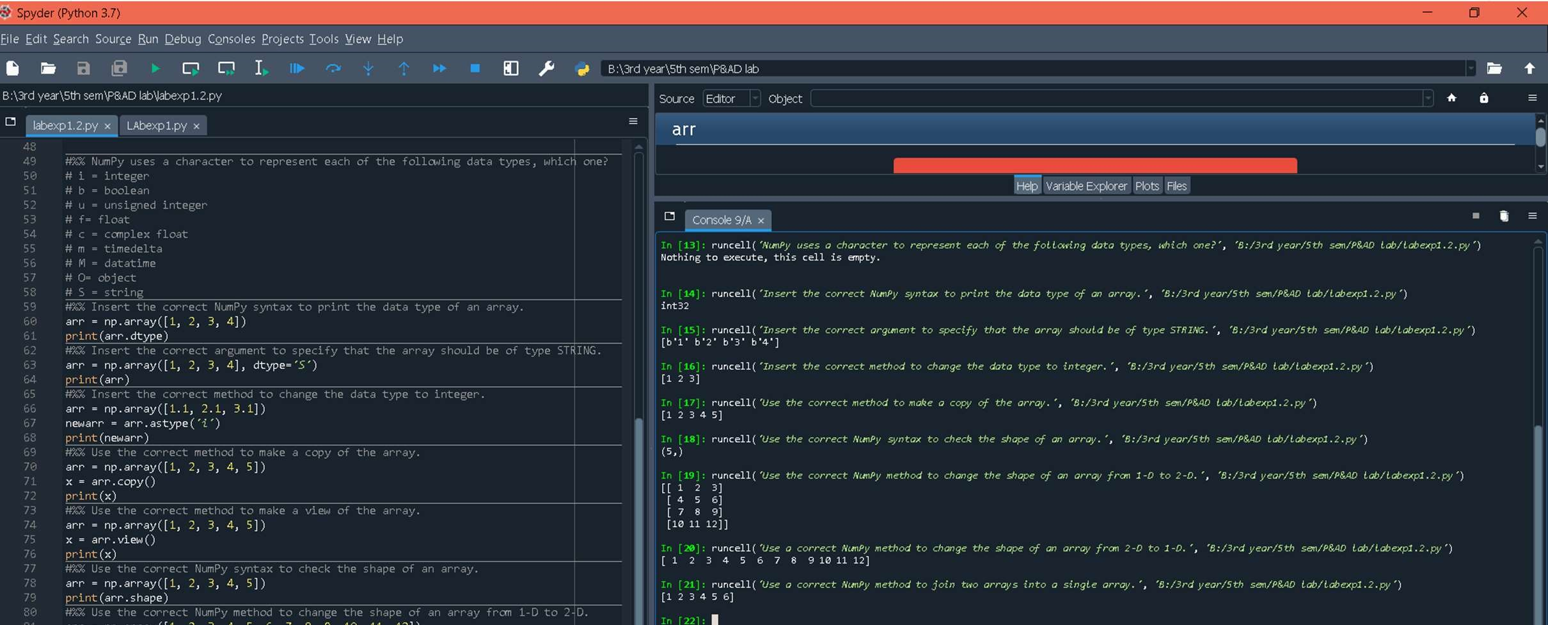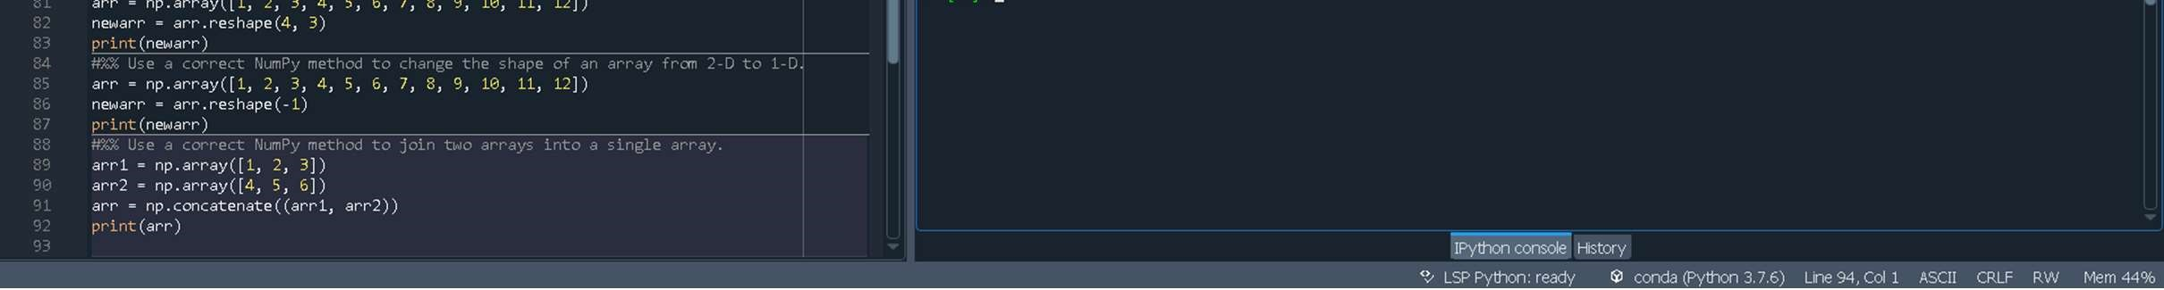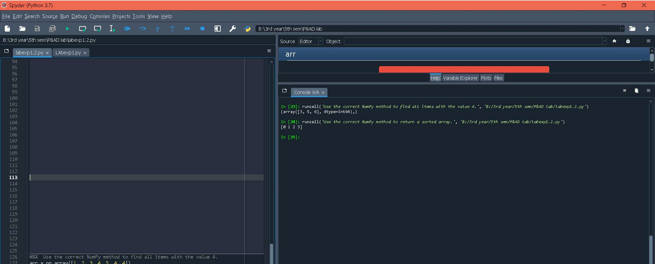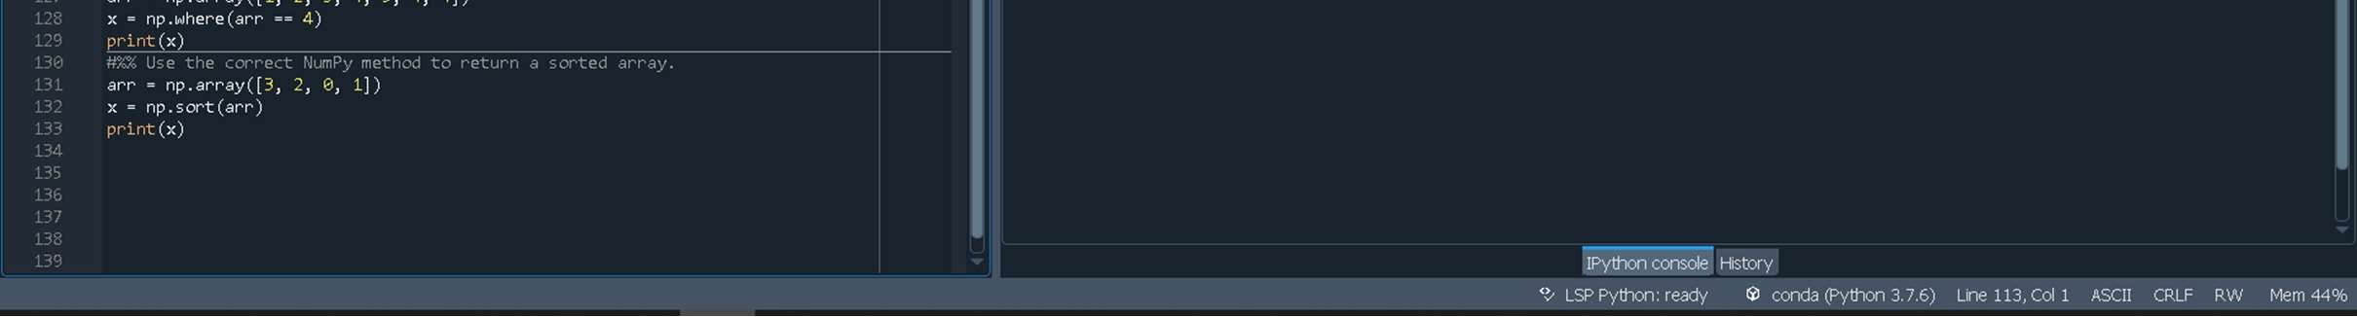

# Experiment 3

AIM:

To perform Linear Regression (OLS Model)

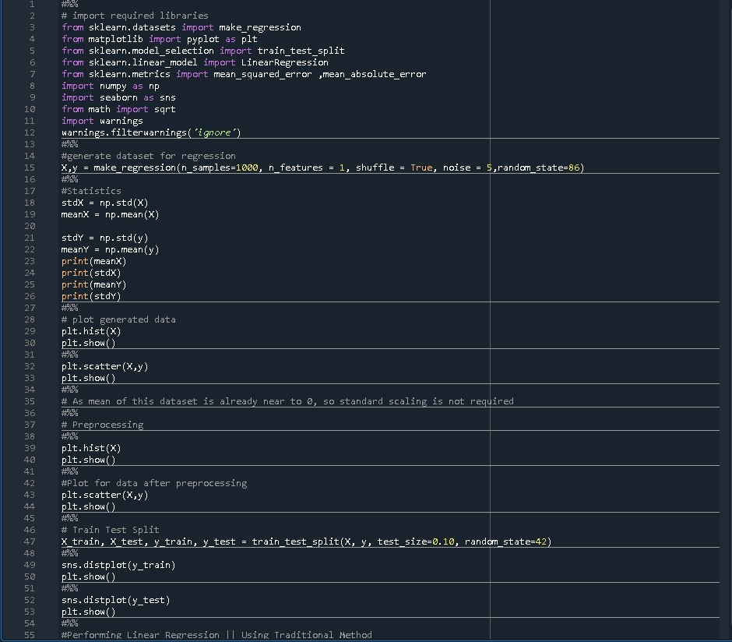CODE:

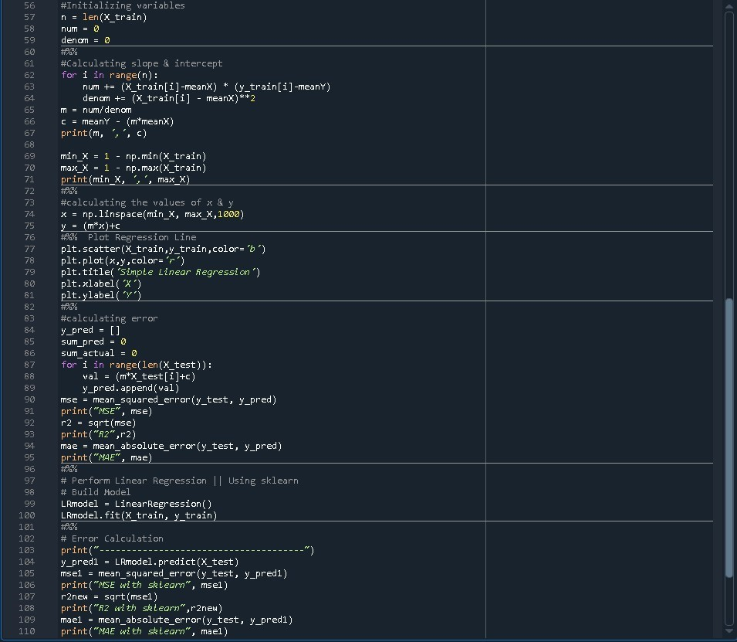

Output: 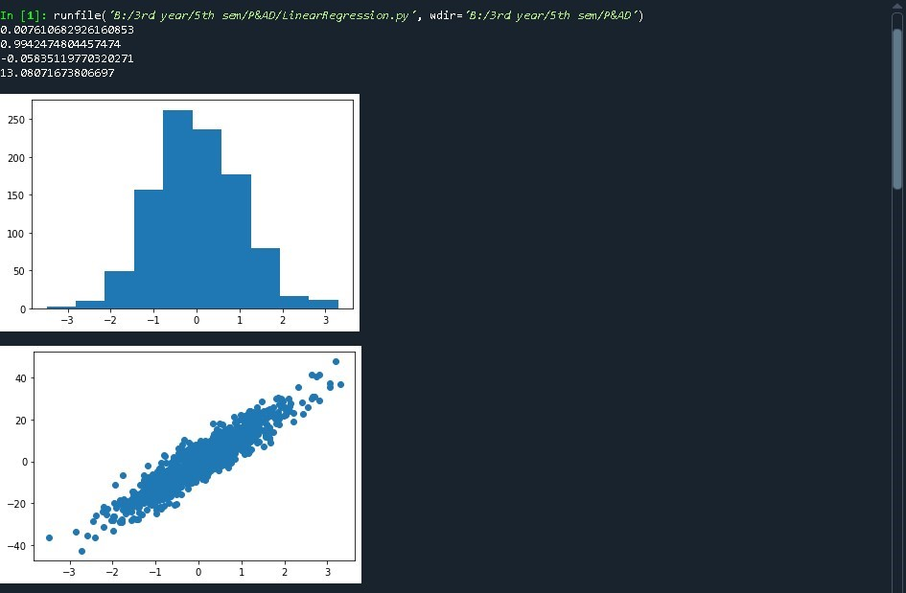

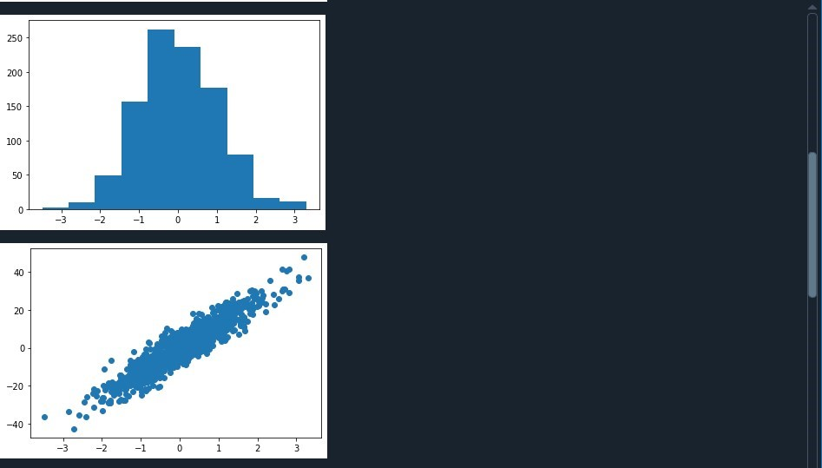

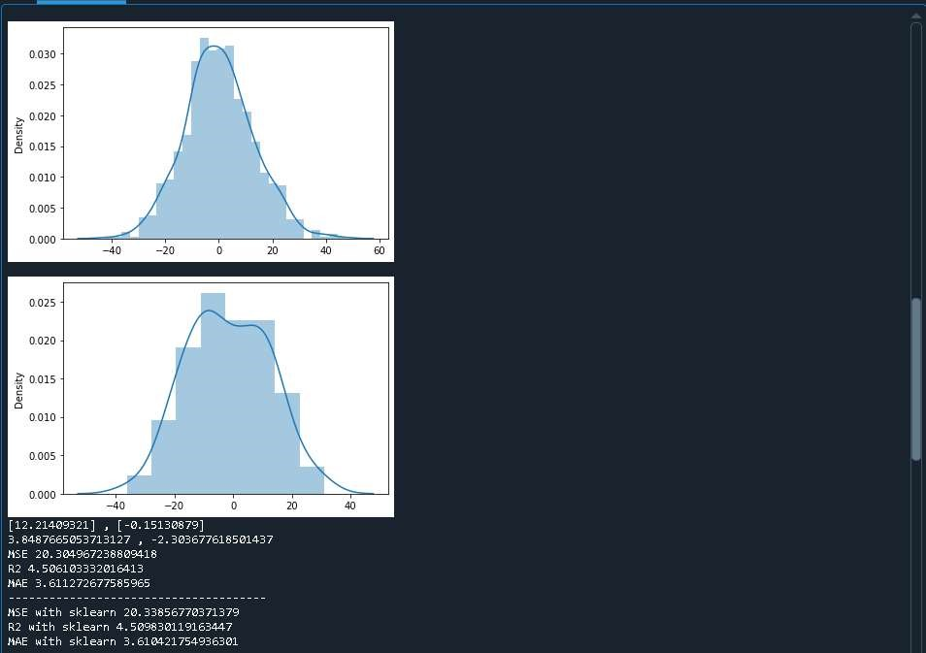

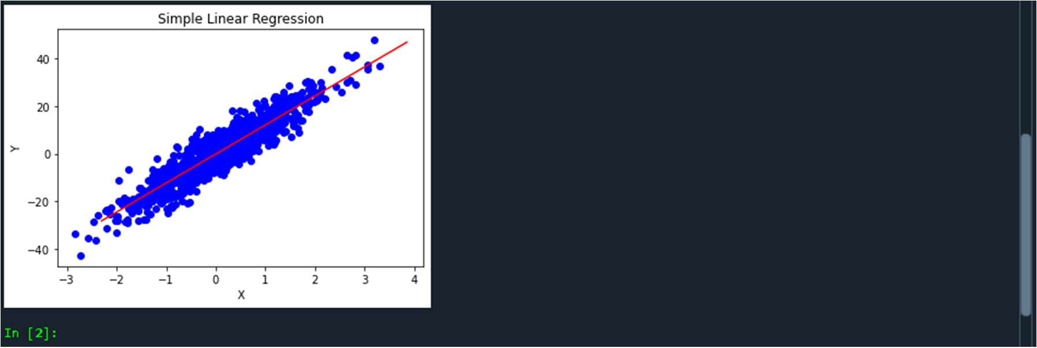

# Experiment 4

AIM:

To perform Logistic Regression

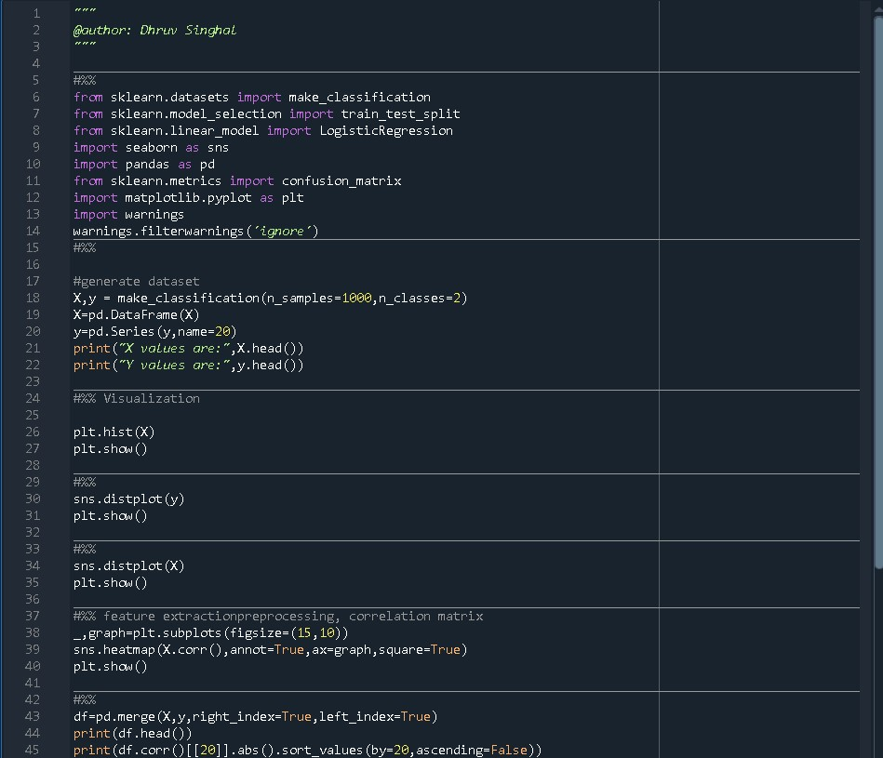**CODE:**

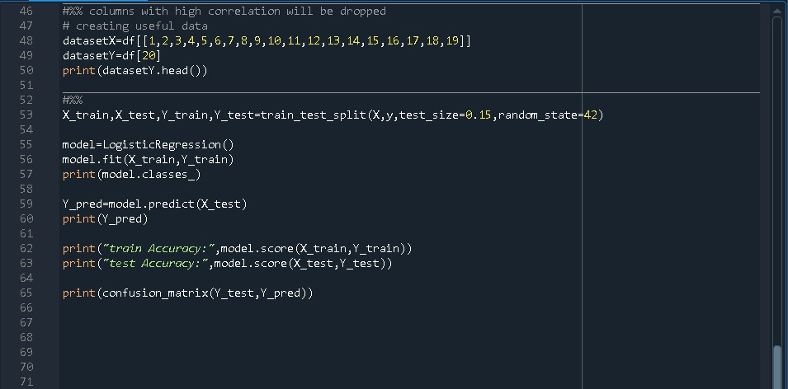

**OUTPUT:**

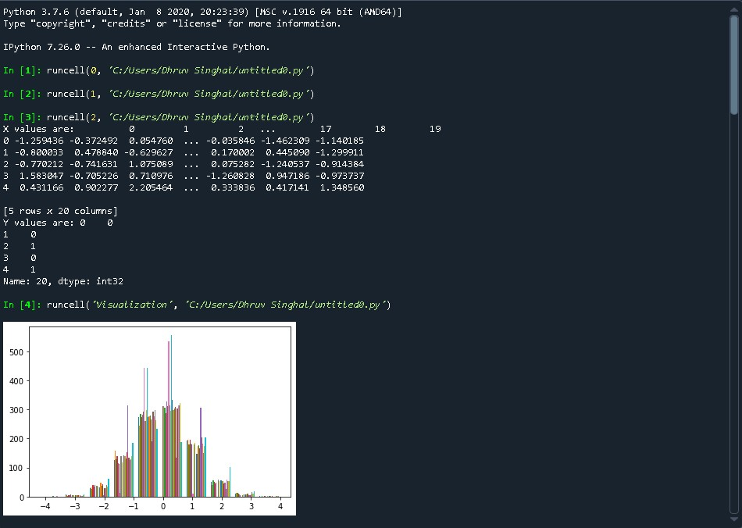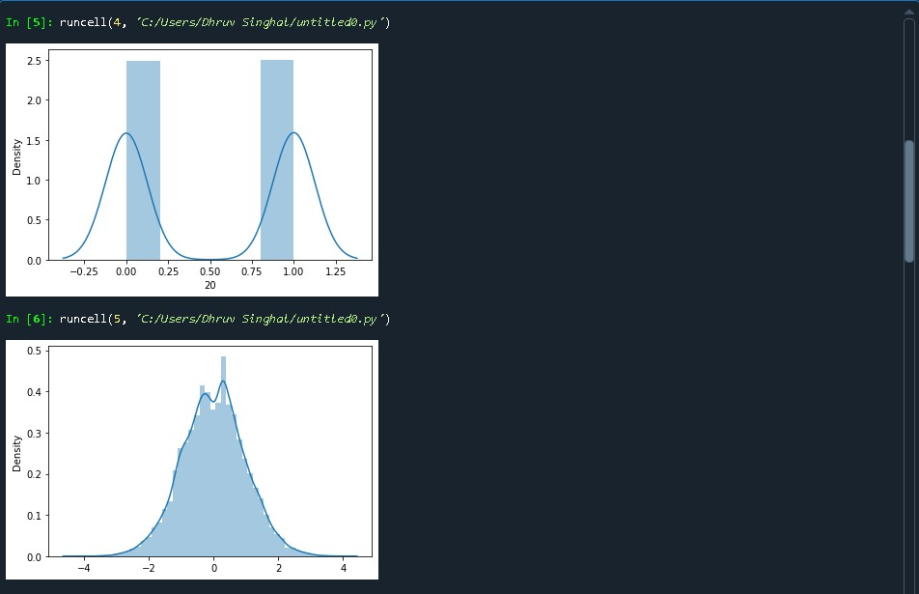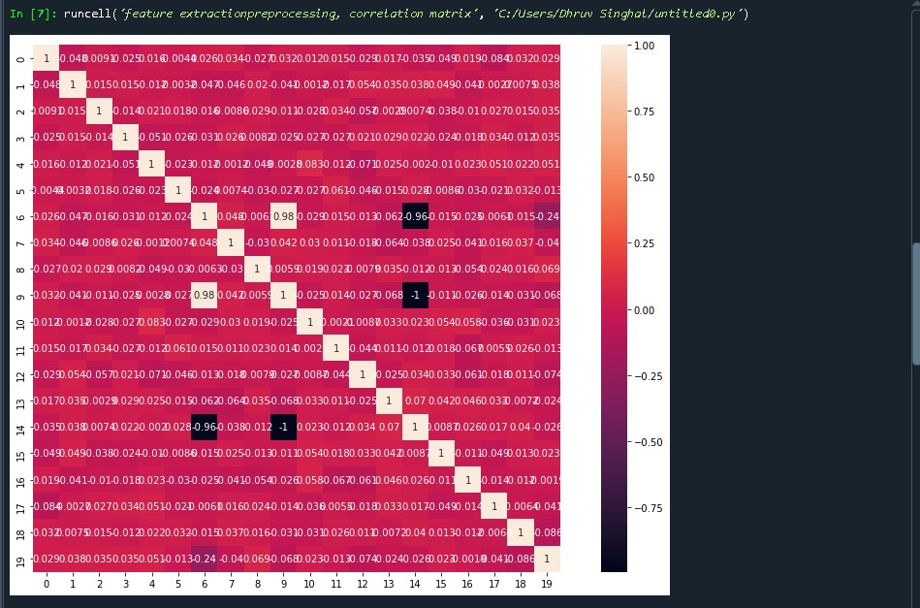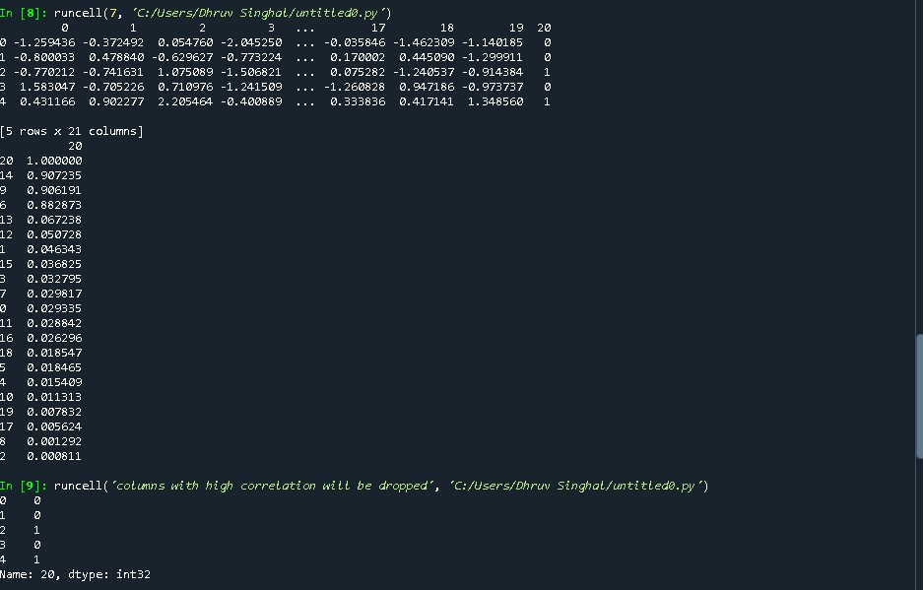

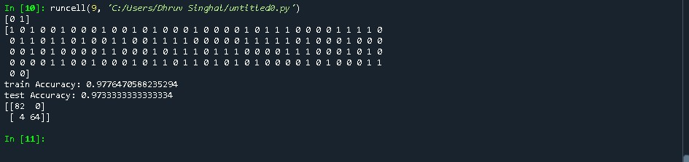

# Experiment 5

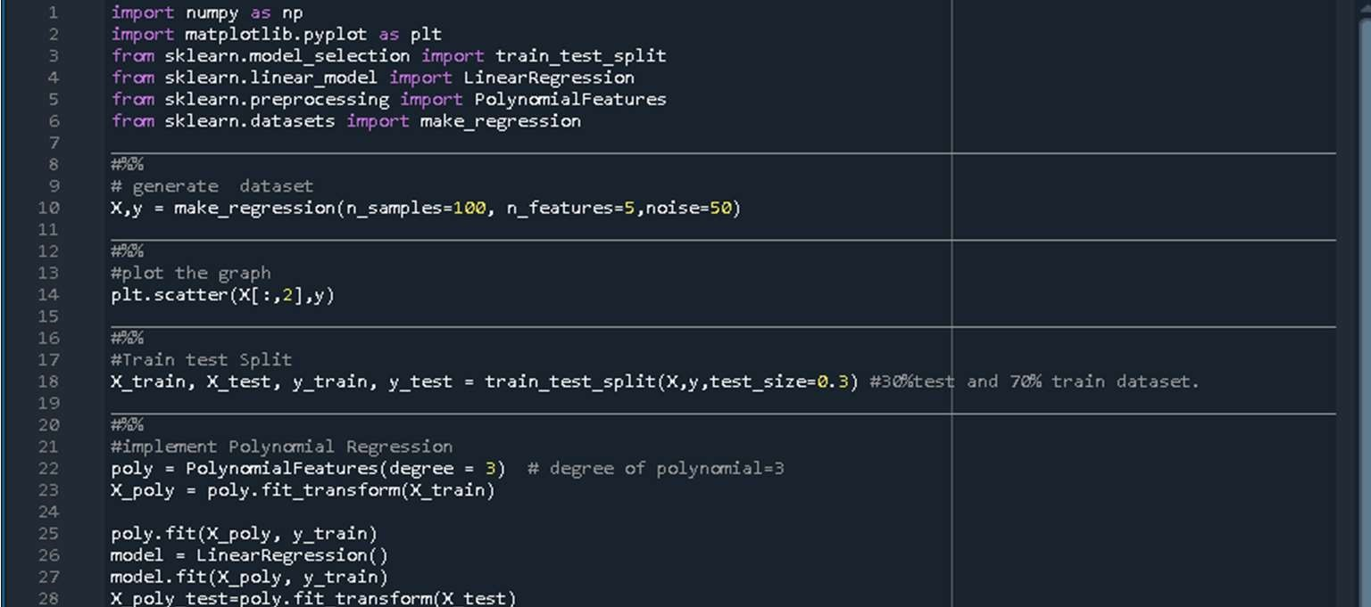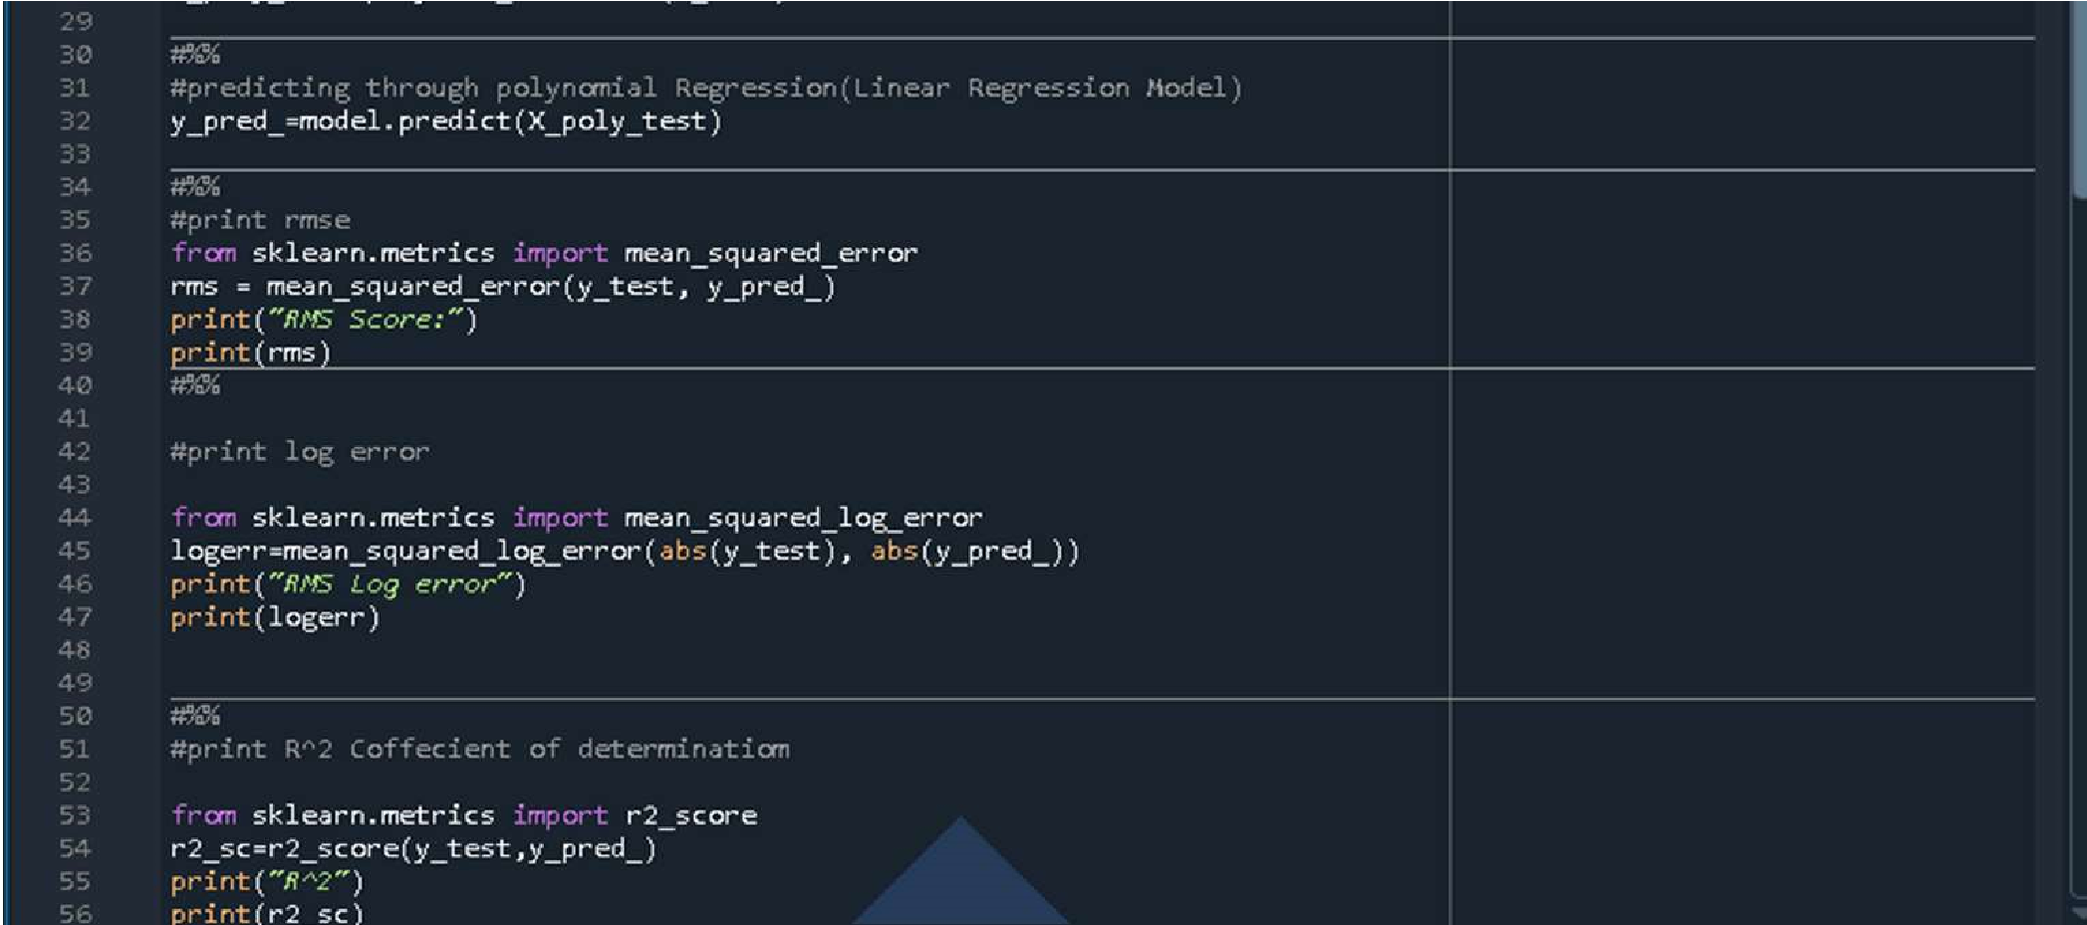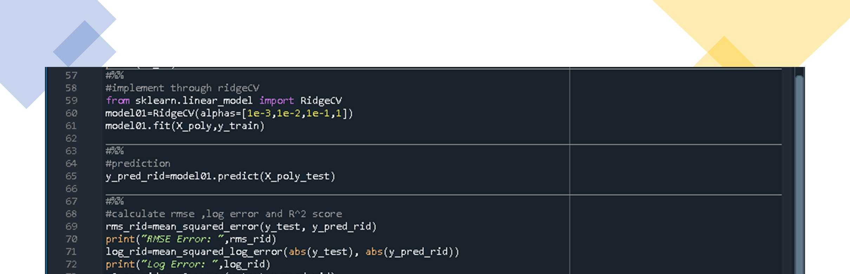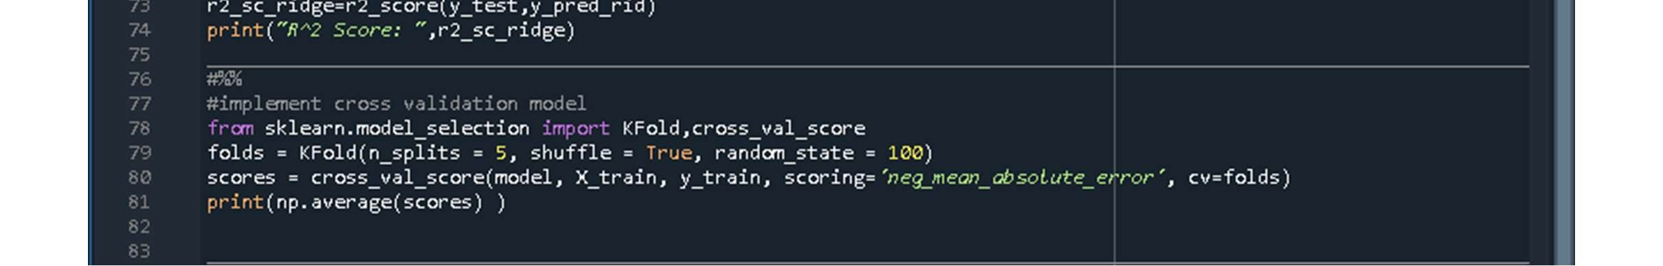

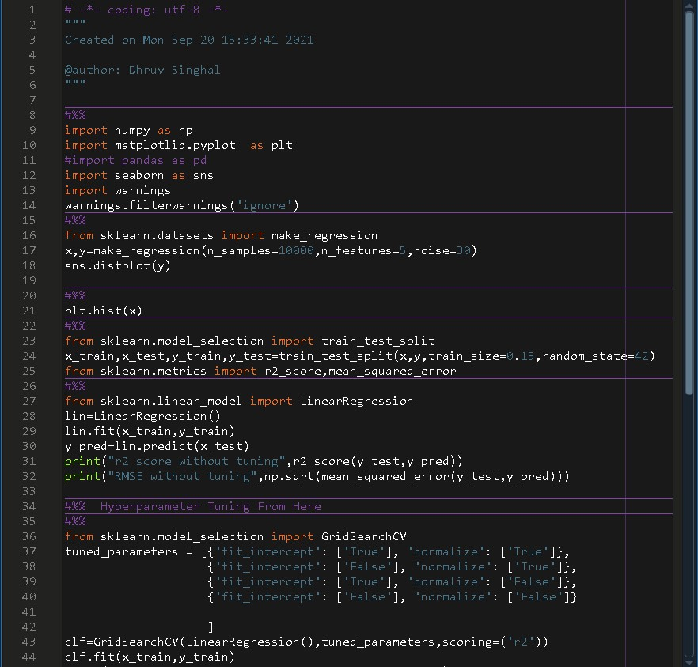**Experiment 7**

# 

# Experiment 6

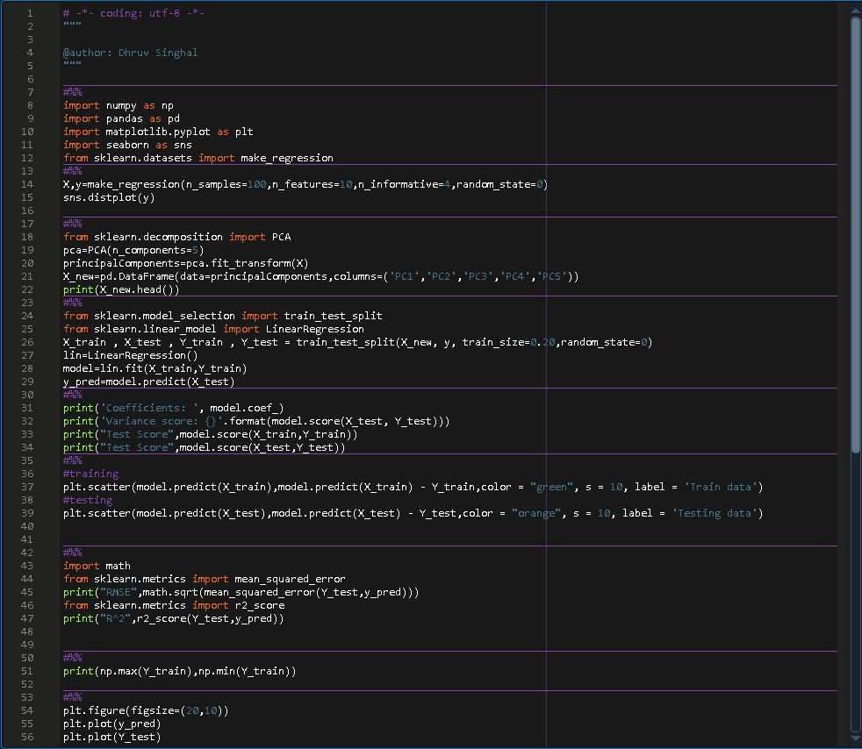CODE:

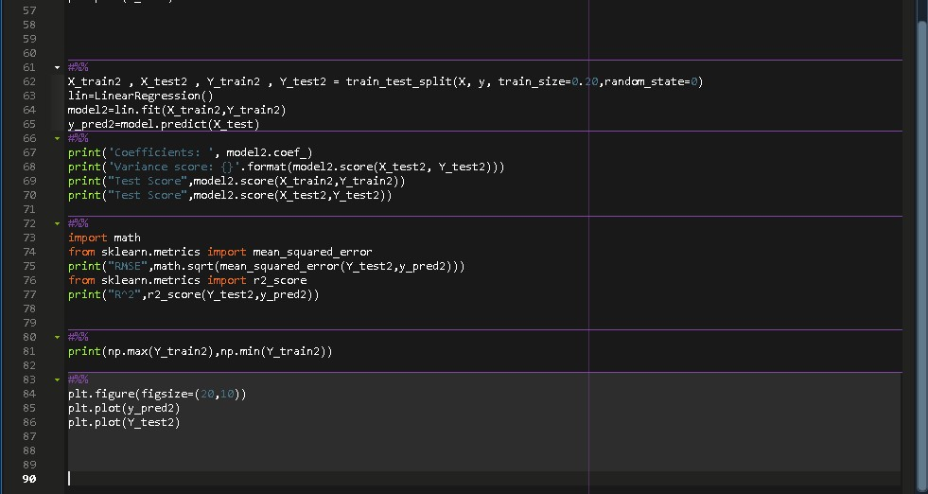

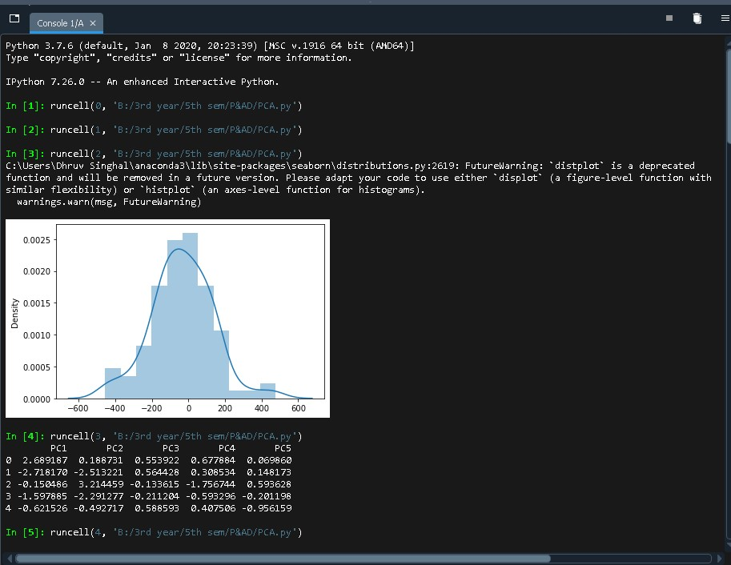OUTPUT:

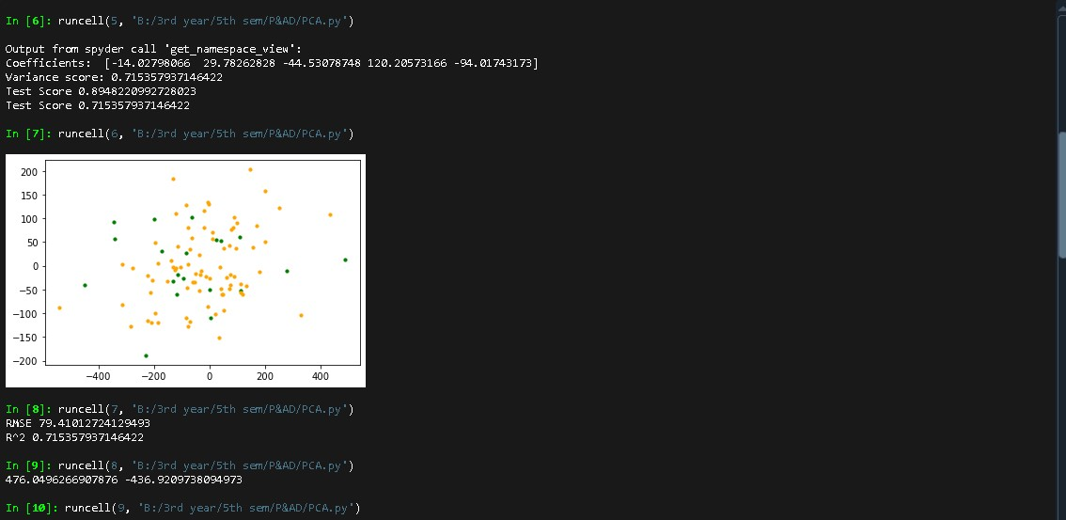

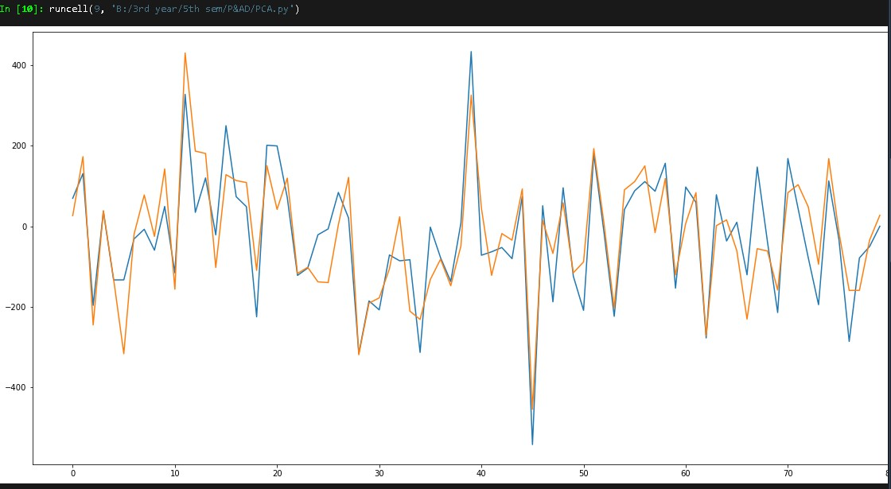

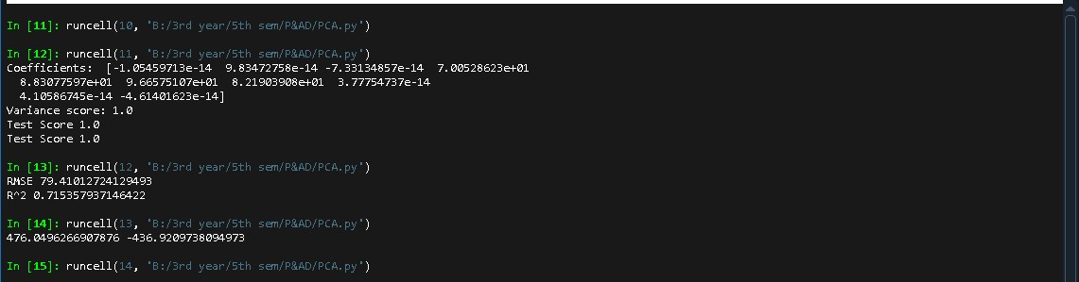

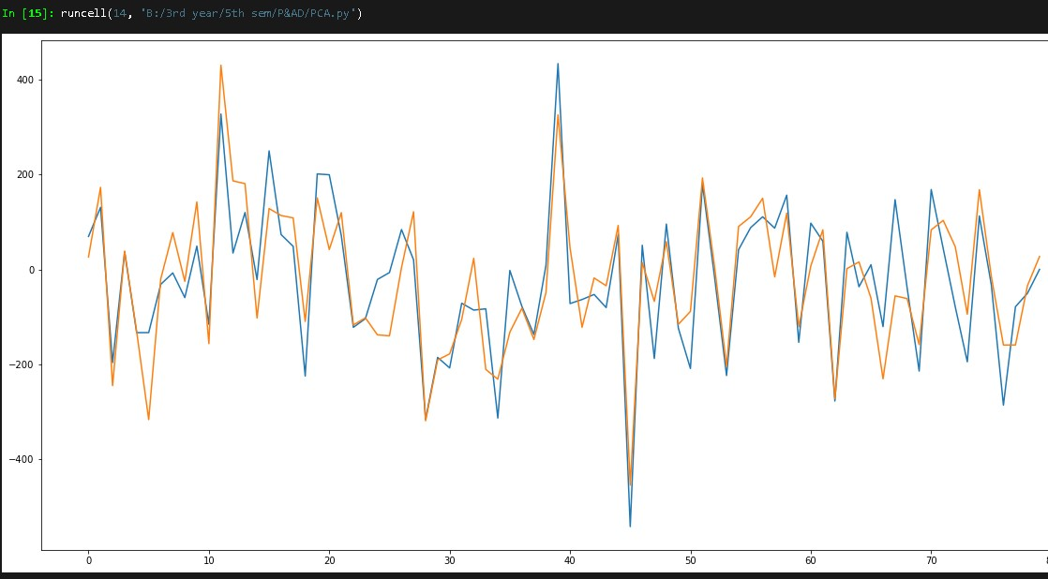

**Experiment 8**

**Hyperparameter**

**Tuning and Nested Cross validation on**

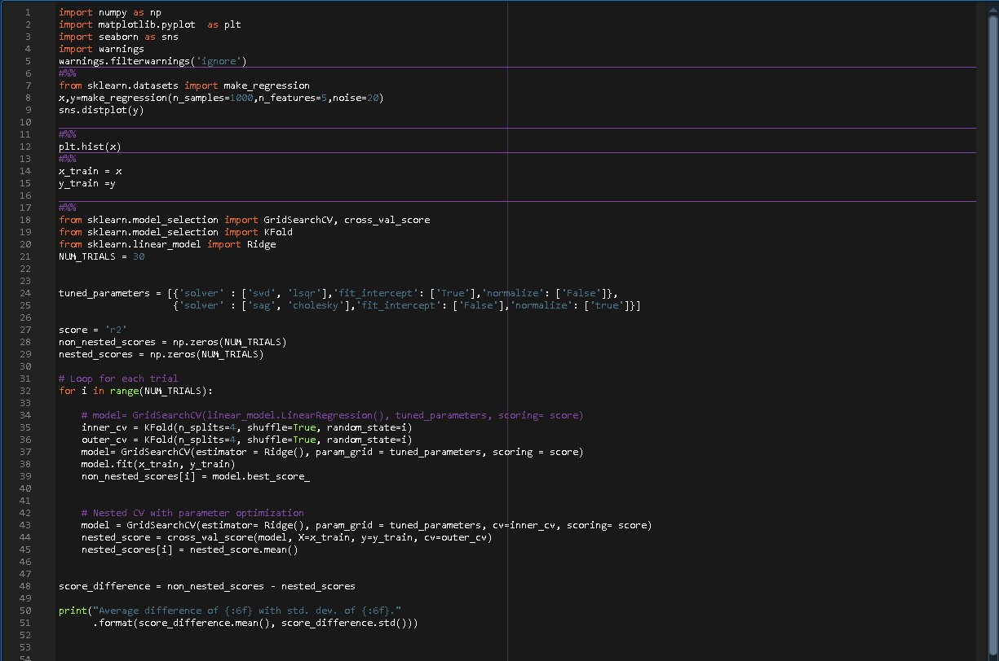**Linear Regression**

**CODE:**

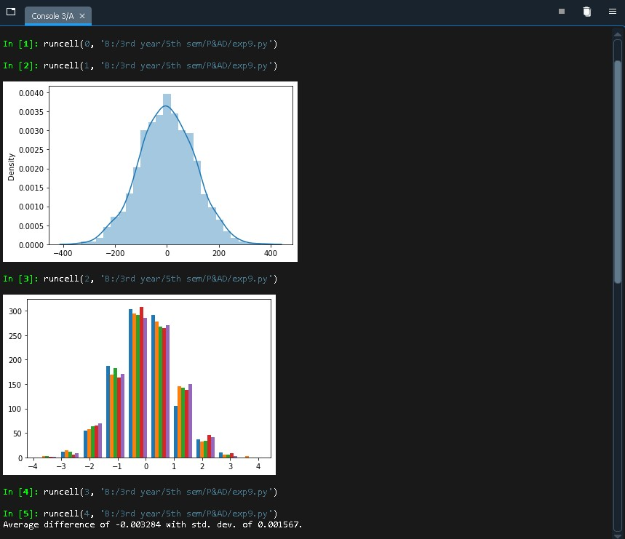OUTPUT:

**Hyperparameter**

**Tuning and Nested Cross validation on**

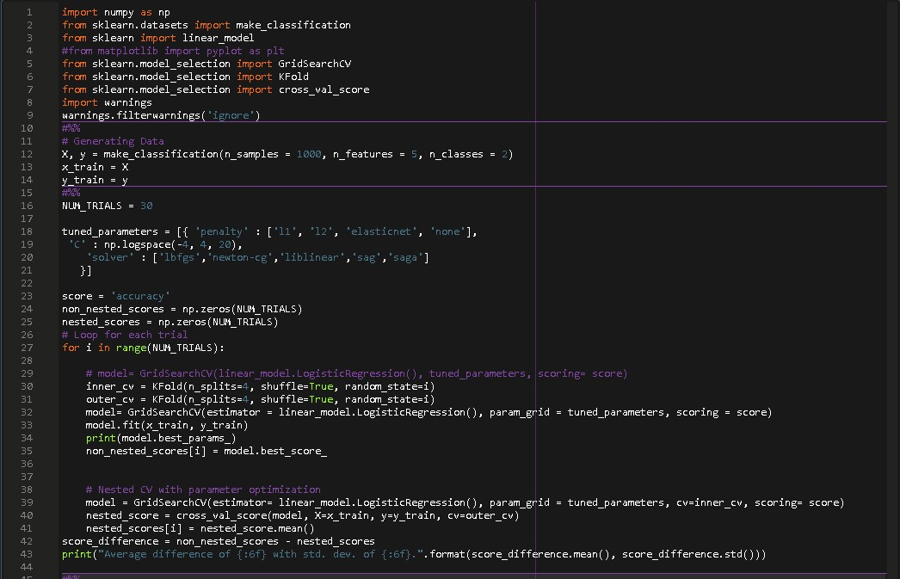**Logistic Regression**

**CODE:**

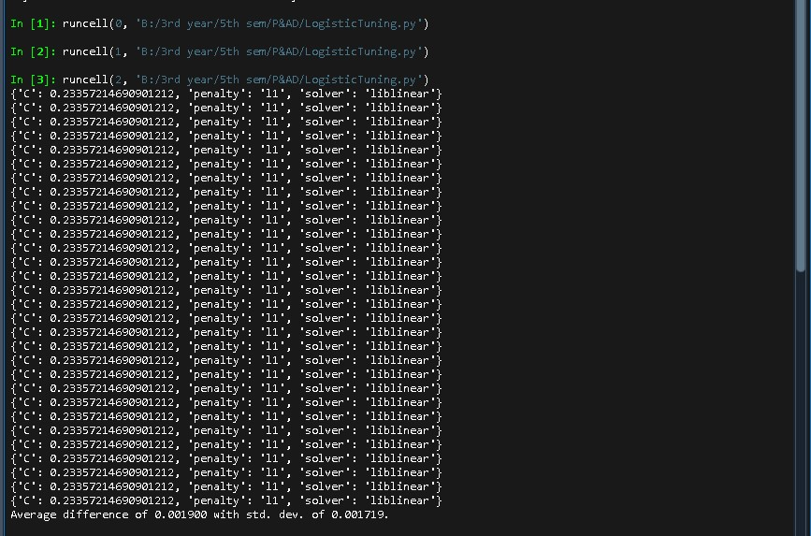OUTPUT:

**Hyperparameter**

**Tuning and Nested Cross validation on**

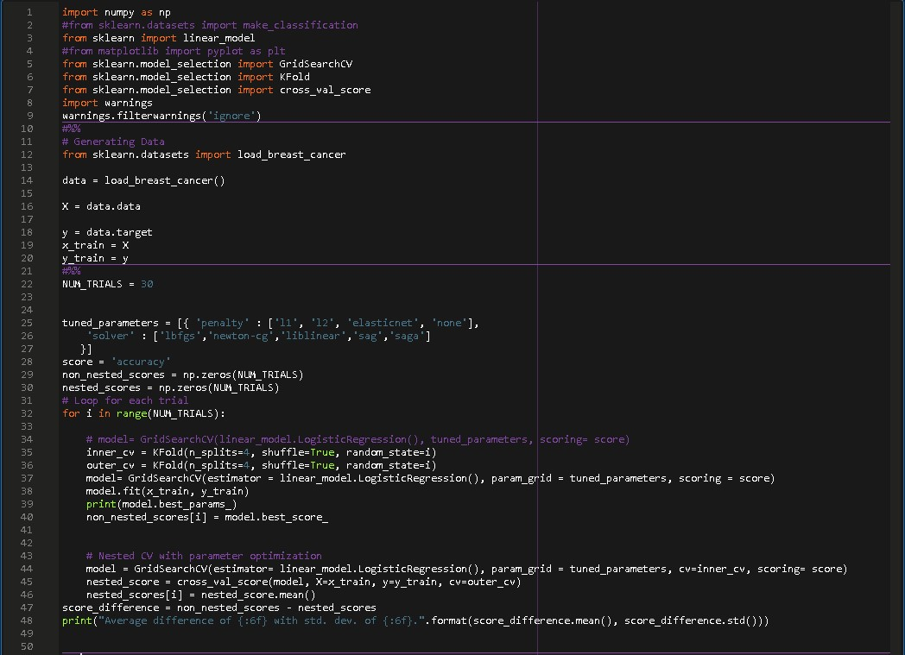**Logistic Regression**

**(Breast Cancer Dataset)**

**CODE:**

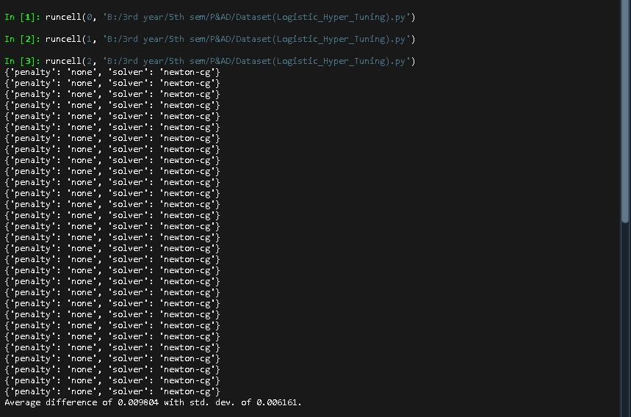OUTPUT:

**Experiment 9**

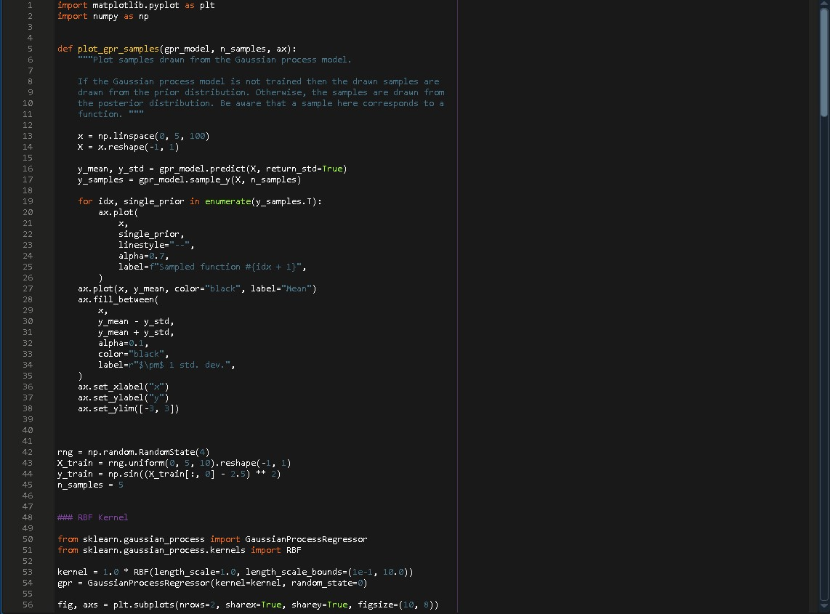CODE:

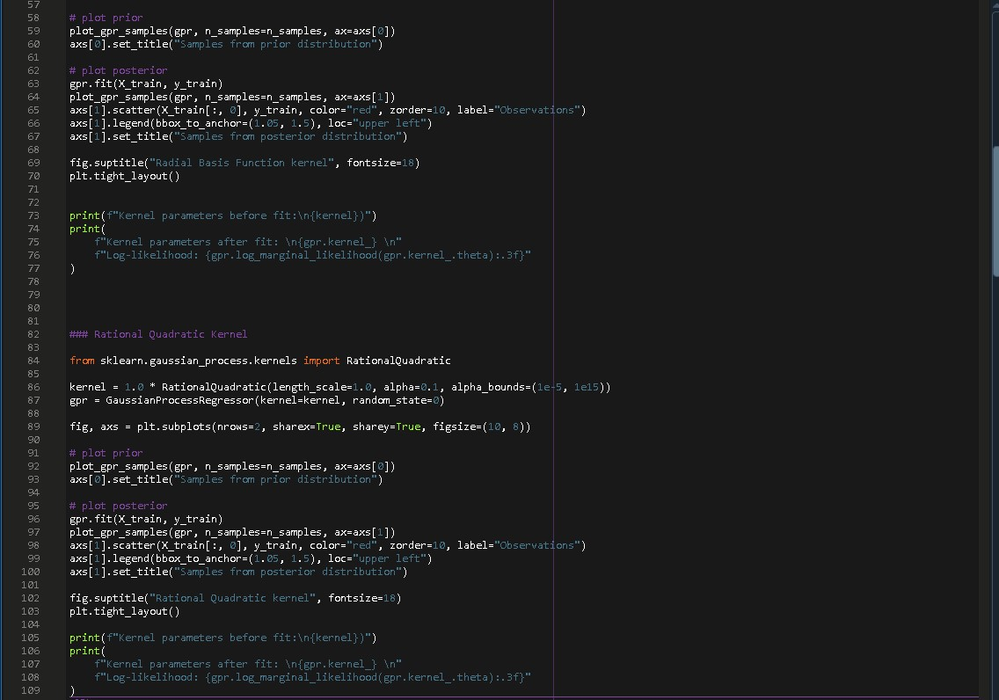

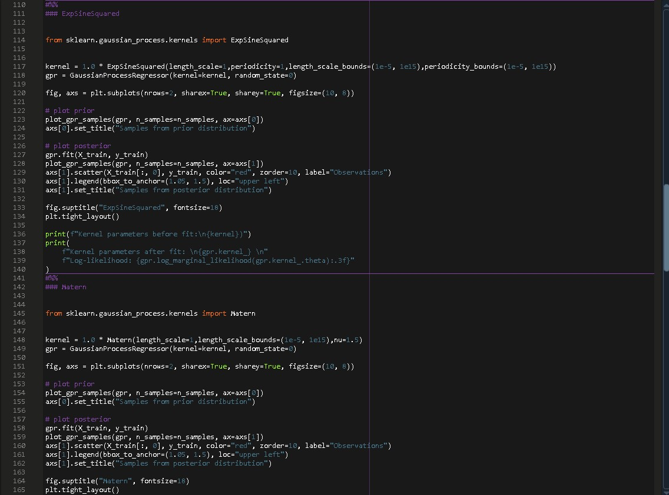

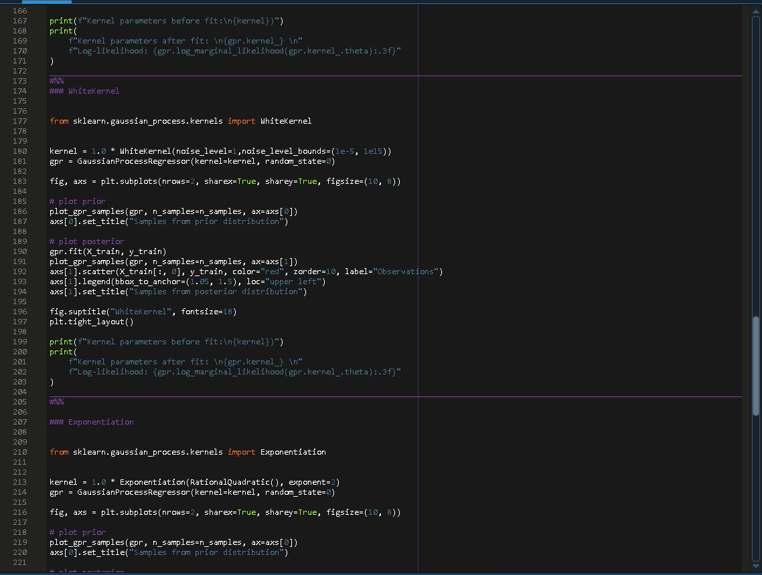

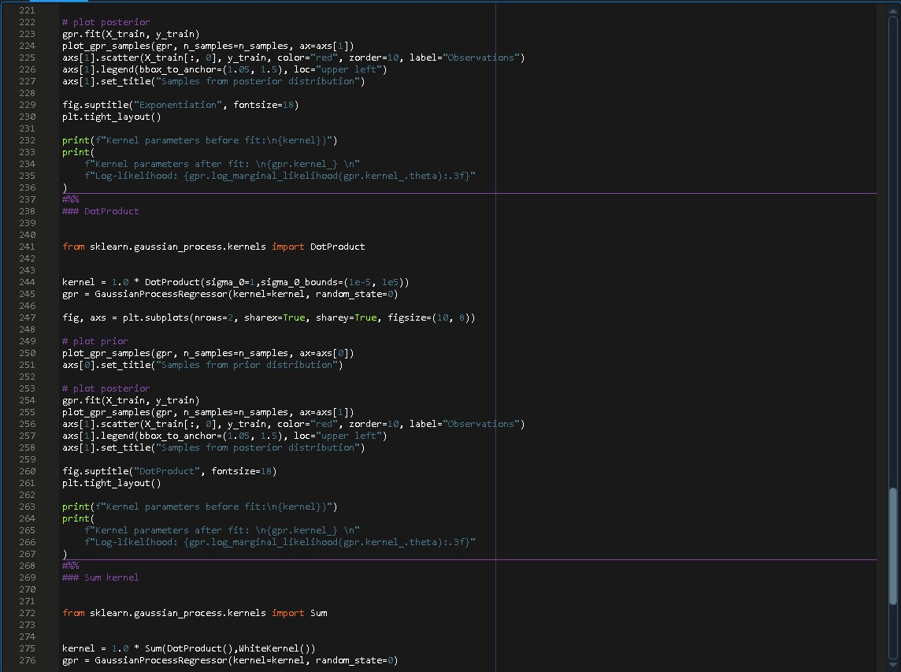

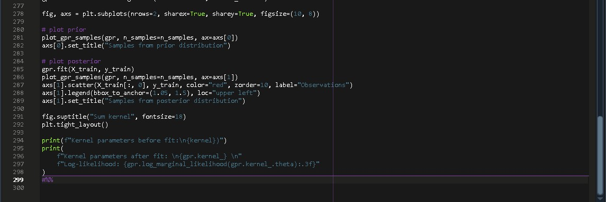

OUTPUT:

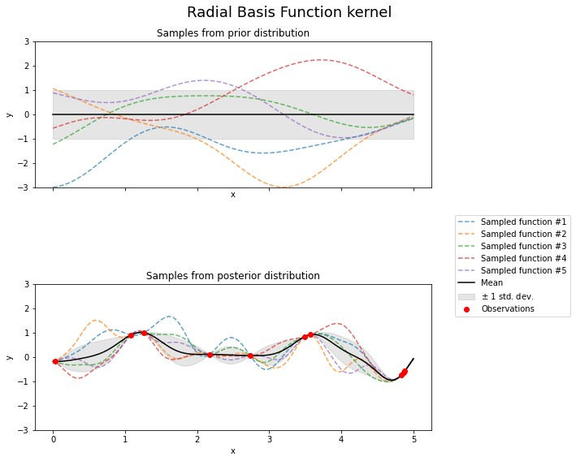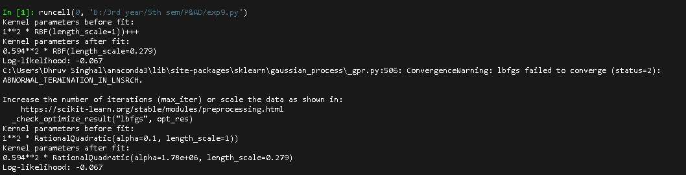

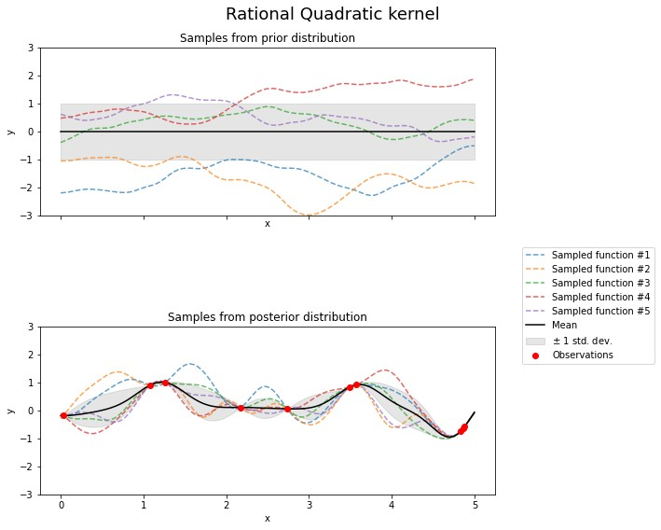

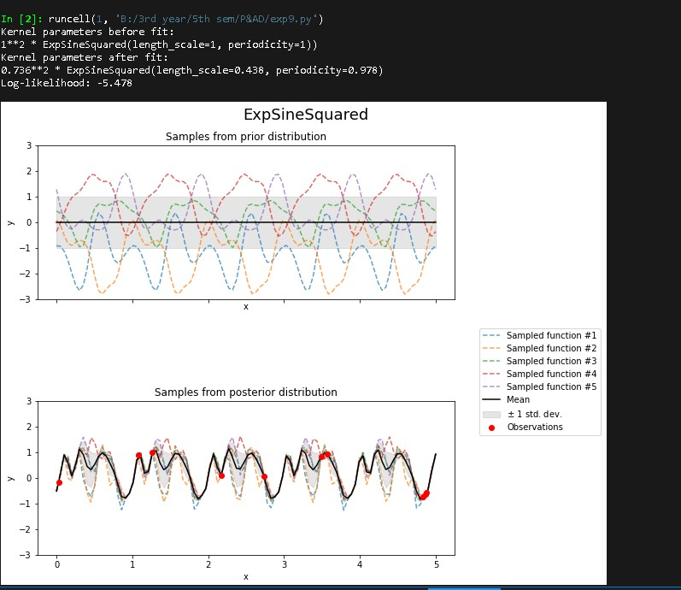

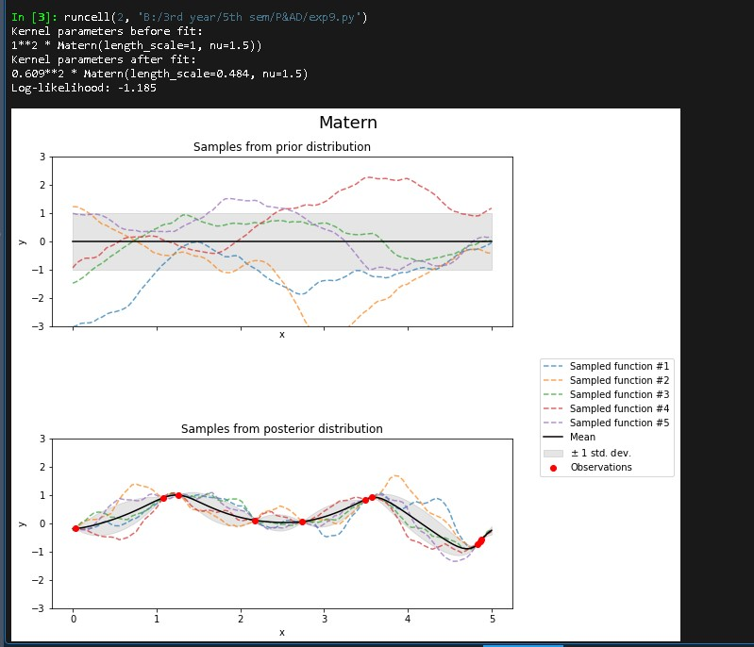

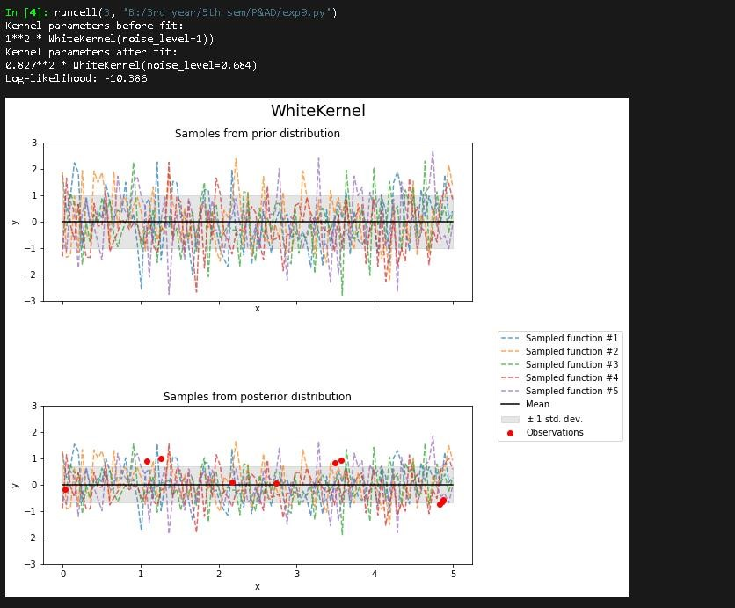

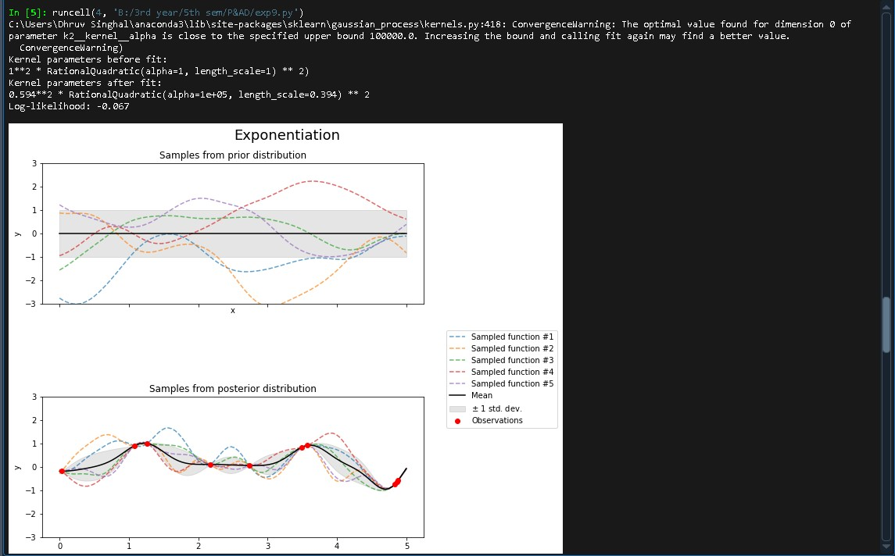

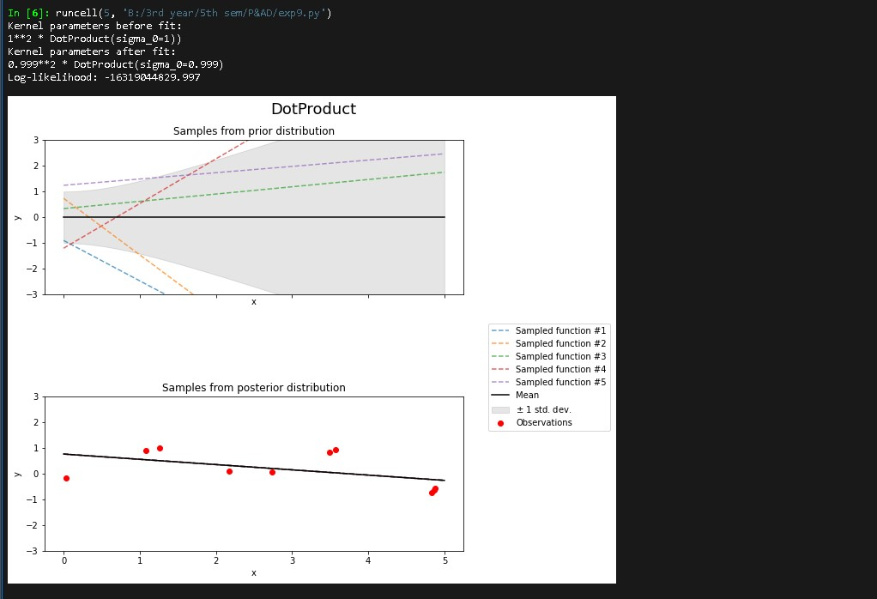

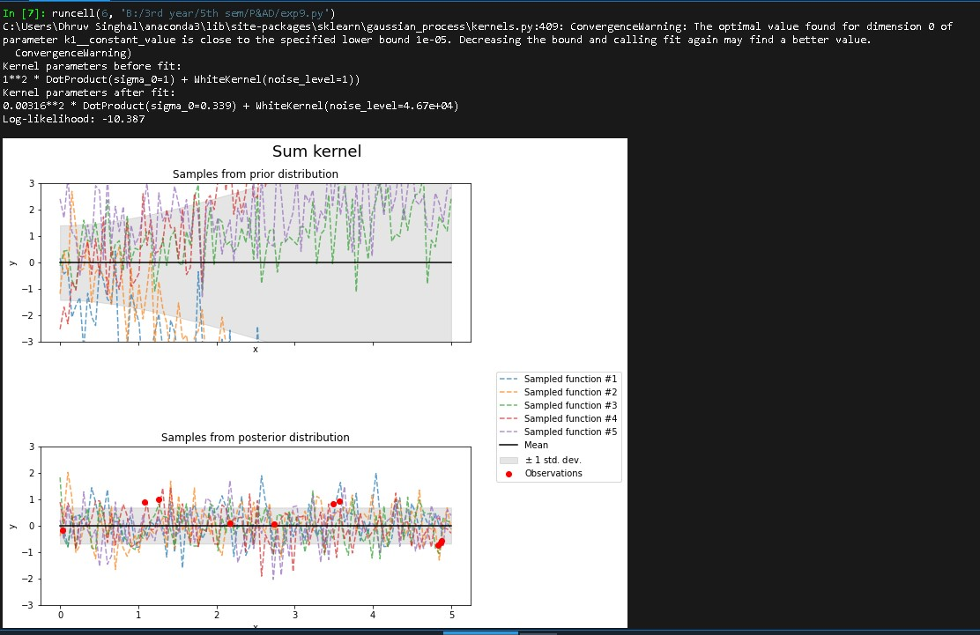

**Experiment 10**

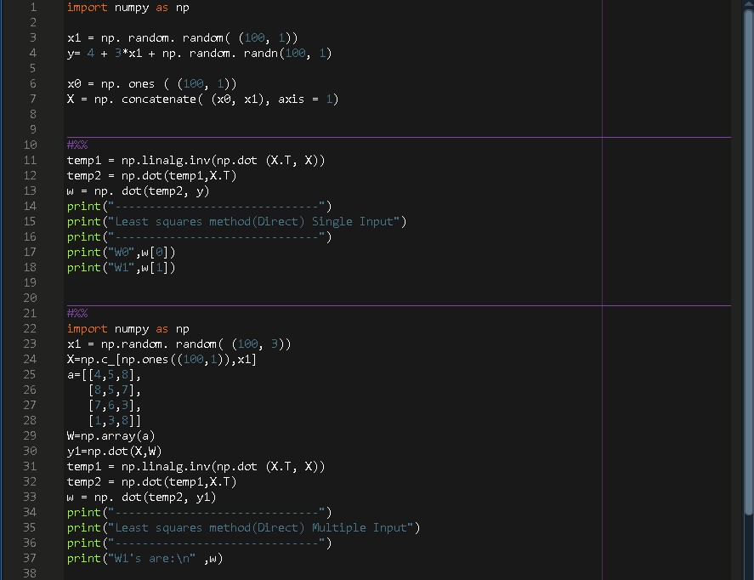CODE:

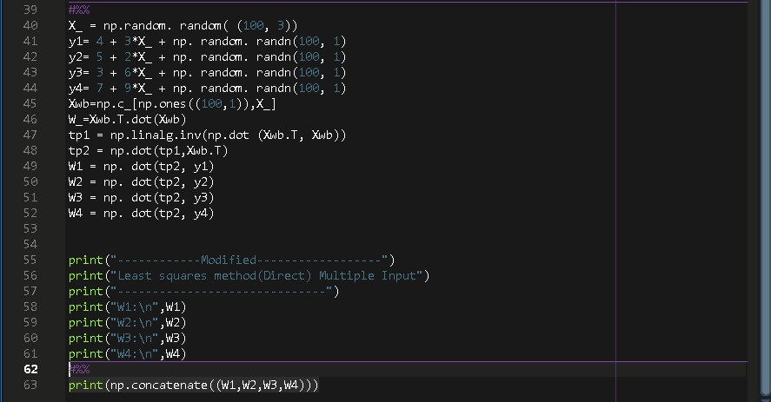

OUTPUT:

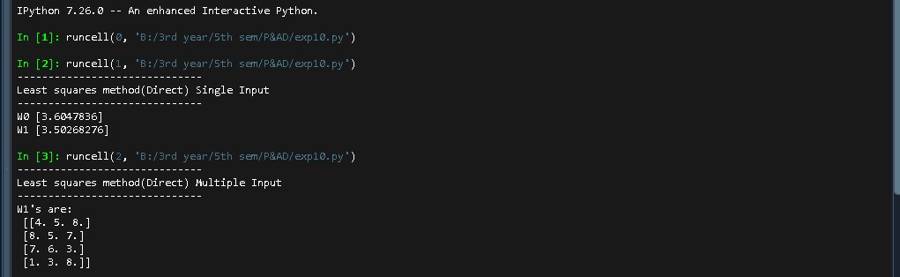

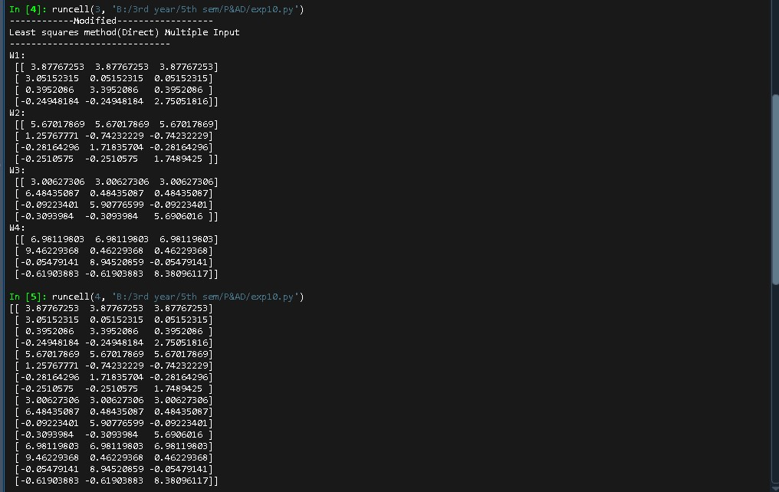

# Experiment 11

**Different Anomaly Detection Algorithms on 2D Dataset**

# Importing required libraries

In

[3]:

**import**

time

**import**

numpy

**as**

np

**import**

matplotlib

**import**

matplotlib

.

pyplot

**as**

plt

**from**

sklearn

**import**

svm

**from**

sklearn

.

datasets

**import**

make_moons

,

make_blobs

**from**

sklearn

.

covariance

**import**

EllipticEnvelope

**from**

sklearn

.

ensemble

**import**

IsolationForest

**from**

sklearn

.

neighbors

**import**

LocalOutlierFactor

# Data

for this experiment we have use make_moons, make_blobs datsets which are already in sklearn.datasets

sklearn.datasets.make_blobs(n_samples=100, n_features=2, *, centers=None, cluster_std=1.0, center_box=(- 10.0, 10.0), shuffle=True, random_state=None, return_centers=False) Generate isotropic Gaussian blobs for clustering.

sklearn.datasets.make_moons(n_samples=100, *, shuffle=True, noise=None, random_state=None) Make two interleaving half circles. A simple toy dataset to visualize clustering and classification algorithms.

**Preprocessing & Visualization**

for this experiment we do not need preprocessing as we need to visualize different anomaly detection algorithms

# Model Building

## Covariance Matrix

This metric assesses how many standard deviations σ away xᵢ is from μ, thereby being dimensionless. An extreme observation has a large distance from the center of a distribution. It is useful in predictive maintenance as it enables finding unusual behavior of a system; upcoming down-times and malfunction can be targeted and identified, which is particularly important since finding faults in equipment, machines, and devices early can reduce the extent of the damage.

## One Class SVM

One Class SVM mode is trained in only one class, referred to as the normal class. The model learns all the features and patterns of the normal class . When a new observation is introduced to the model, then based on its learning, the One Class SVM detects if the new observation deviates from the normal behaviour then it classifies it as an oulier else the new observation will identified as an inlier. One Class SVM is based on Support Vector Machines where the binary classes are separated by a non-linear hyper plane

## Local Outlier Factor

Local outlier factor (LOF) is an algorithm used for Unsupervised outlier detection. It produces an anomaly score that represents data points which are outliers in the data set. It does this by measuring the local density deviation of a given data point with respect to the data points near it.

## Isolation Forest

Isolation Forest is based on the Decision Tree algorithm. It isolates the outliers by randomly selecting a feature from the given set of features and then randomly selecting a split value between the max and min values of that feature. This random partitioning of features will produce shorter paths in trees for the anomalous data points, thus distinguishing them from the rest of the data.

## Compile & Train

Altering the hyperparameters to see the effect of the hyperparameter on the working of the algorithm

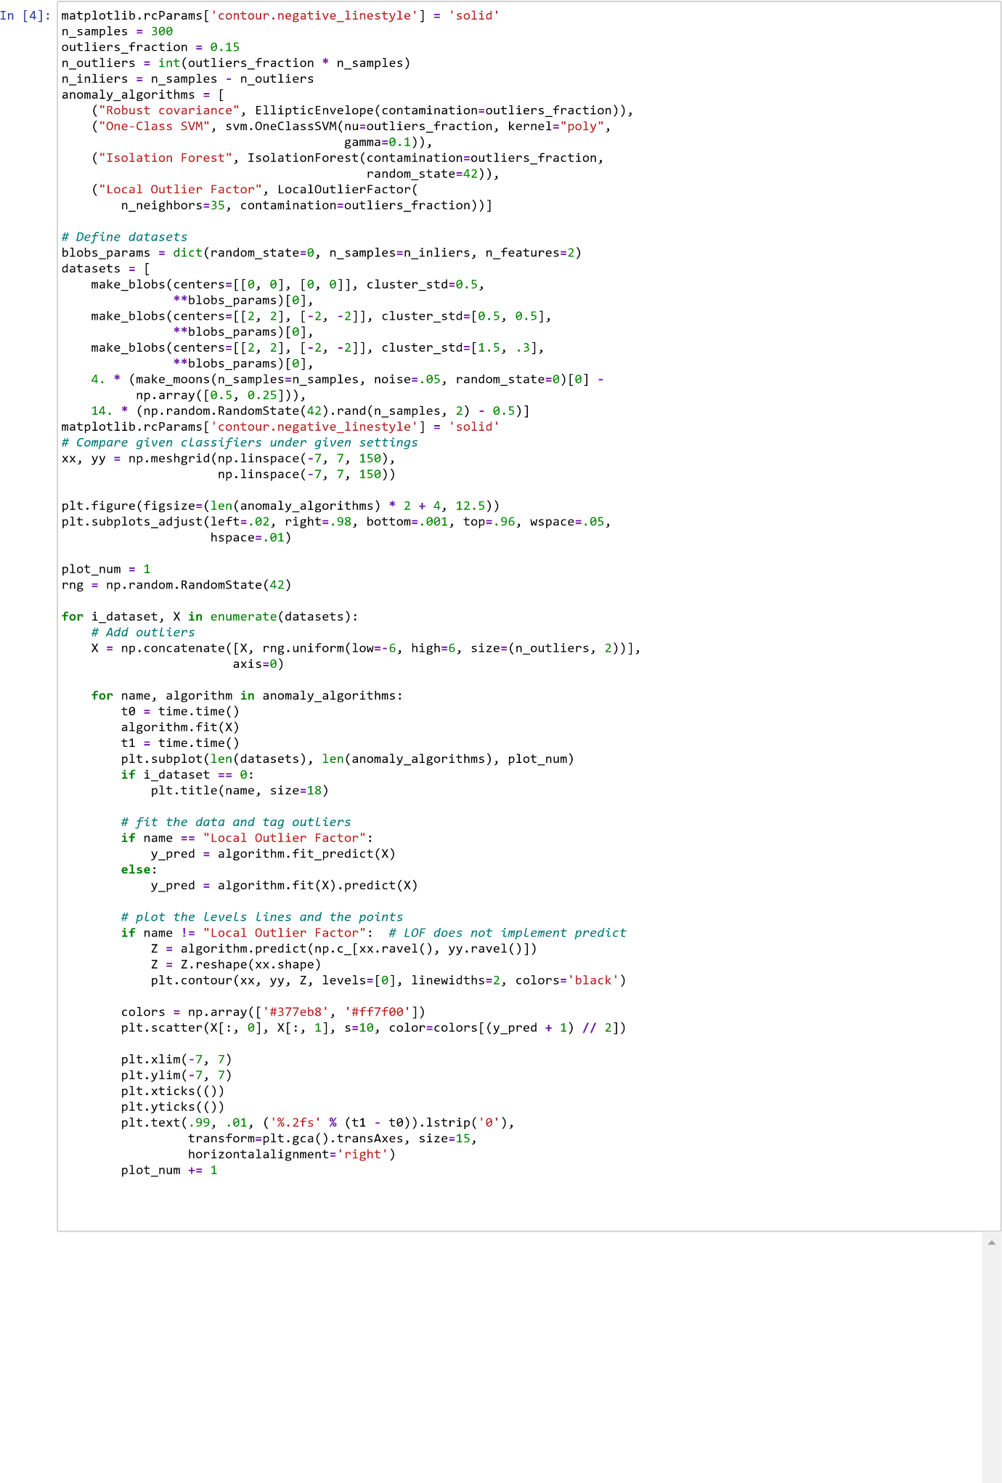

# Result

By this experiment i came to know the working of different anomaly detection algorithms and how they differ from each other in working and in time perspective how they find anomaly

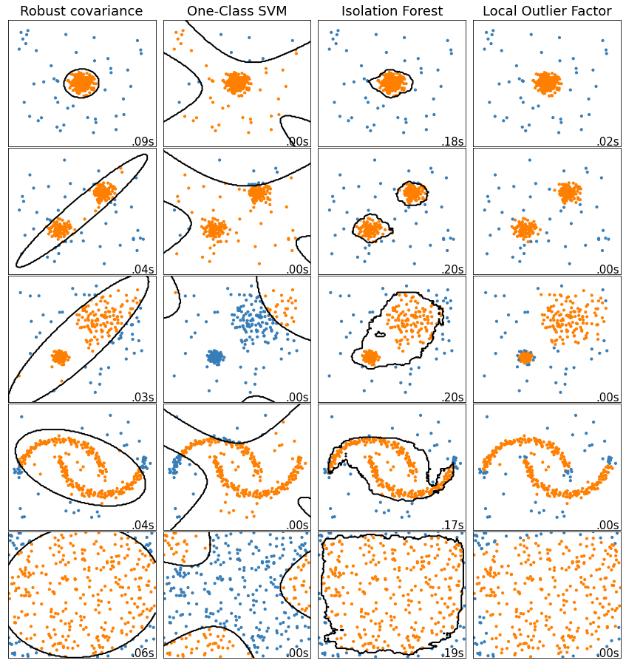In [ ]:

**Experiment 12**

**Support Vector Machines**

# Importing required libraries

In

[1]:

**import**

numpy

**as**

np

**import**

matplotlib

.

pyplot

**as**

plt

**from**

sklearn

.

model_selection

**import**

train_test_split

**from**

sklearn

**import**

svm

**from**

sklearn

.

datasets

**import**

make_classification

**from**

sklearn

.

model_selection

**import**

GridSearchCV

**from**

sklearn

.

model_selection

**import**

KFold

**from**

sklearn

.

model_selection

**import**

cross_val_score

# Creating Data

Creating Dataset with 5000 sample points and 2 features and 2 classes and number of informative features are 2 and number of redundant features are 0 and number of repeated features are 0 and random_state is 50 and difference between 2 class is set as 3.5

In [2]: X, y**=** make_classification(n_samples**=**5000,n_features**=**2,n_classes**=**2

,n_informative**=**2,n_redundant**=**0,n_repeated**=**0,random_state**=**0,class_sep**=**2.5)

# Preprocessing & Visualization

since we have created dataset using make_classfiocation , it by default make dataset's mean tending to 0 and Standard Deviation to 1 which doesn't require any preprocessing.

# Model Building

The goal of the SVM algorithm is to create the best line or decision boundary that can segregate n-dimensional space into classes so that we can easily put the new data point in the correct category in the future. This best decision boundary is called a hyperplane.

SVM chooses the extreme points/vectors that help in creating the hyperplane. These extreme cases are called as support vectors, and hence algorithm is termed as Support Vector Machine. In this case we have called the in built function svm.SVC

# Compile & Train

Firstly splitting the input dataset into training and test parts following which training set is passed through svm.SVC and is fitted to it. and predicting over the test test to check the model performance.

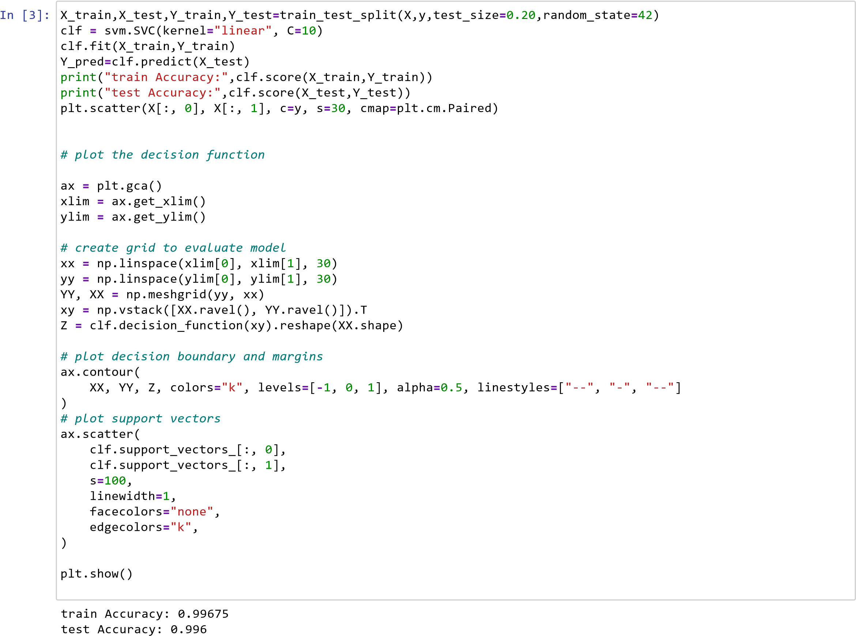

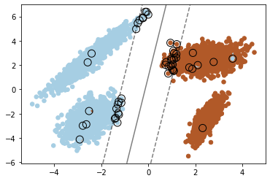

# Result

since training is giving 99.67% accuracy and in testing it is giving 99.60% accuracy so to check if model is overfitting or not or to improve the validation accuracy more and make more generalized model . So to overcome this we are using k fold cross validation and hyperparameter tuning to improve the overall score and generate generalizesd model and knowing which hyperparameter combination gives best overall score

In

[4]:

*#Cross Validation without Hyper parameter Tuning*

clf

**=**

svm

.

SVC

(

kernel

**=**

'linear'

,

C

**=**

2

)

kf

**=**

KFold

(

n_splits

**=**

70

)

score

**=**

cross_val_score

(

clf

,

X

,

y

,

cv

**=**

kf

)

print

(

"Average Cross Validation score ( Accuracy) :{}"

.

format

(

score

.

mean

()))

Average Cross Validation score ( Accuracy) :0.9965906550413592

In

[5]:

Best parameters set found on development set:

*# Hyper parameter tuning on SVM*

tuned_parameters

**=**

[{

'kernel'

:[

"linear"

]

,

'C'

:[

100

,

10

,

20

,

40

,

50

]}

,

{

'kernel'

:[

"rbf"

]

,

'C'

:[

90

,

40

,

50

,

100

,

90

]}

,

]

clf

**=**

GridSearchCV

(

svm

.

SVC

()

,

tuned_parameters

,

scoring

**=**

(

'accuracy'

))

clf

.

fit

(

X

,

y

)

print

(

"Best parameters set found on development set:"

)

print

()

print

(

clf

.

best_params_

)

print

()

print

(

"Best Score:"

,

clf

.

best_score_

)

{'C': 100, 'kernel': 'linear'}

In

[6]:

Best Score: 0.9966000000000002

Best parameters set found on development set:

*#%% kfold cross validation with hyperparameter tuning*

k

**=**

5

kf

**=**

KFold

(

n_splits

**=**

k

,

random_state

**=**

**None**

)

model

**=**

GridSearchCV

(

svm

.

SVC

()

,

tuned_parameters

,

scoring

**=**

(

'accuracy'

))

**for**

train_index

,

test_index

**in**

kf

.

split

(

X

):

X_train

,

X_test

**=**

X

[

train_index

,:],

X

[

test_index

,:]

y_train

,

y_test

**=**

y

[

train_index

]

,

y

[

test_index

]

model

.

fit

(

X_train

,

y_train

)

pred_values

**=**

model

.

predict

(

X_test

)

print

(

"Best parameters set found on development set:"

)

print

()

print

(

model

.

best_params_

)

print

()

print

(

"Best Score:"

,

model

.

best_score_

)

{'C': 100, 'kernel': 'linear'}

Best Score: 0.9964999999999999

Now the overall score is 99.649% accuracy

In [ ]:

**Experiment 13**

**Random Forest Classfier**

# Importing required libraries

In

[1]:

**from**

sklearn

.

datasets

**import**

make_classification

**from**

sklearn

.

model_selection

**import**

train_test_split

**from**

sklearn

.

ensemble

**import**

RandomForestClassifier

**import**

seaborn

**as**

sns

**import**

pandas

**as**

pd

**import**

matplotlib

.

pyplot

**as**

plt

**import**

warnings

warnings

.

filterwarnings

(

'ignore'

)

# Data creation

Creating Dataset using make_classfication with 5000 sample points and 5 classes with 20 number of features in which 10 are informative features and 5 are redundant features and shuffling is turned ON

In

[2]:

X

,

y

**=**

make_classification

(

n_samples

**=**

5000

,

n_classes

**=**

5

,

n_features

**=**

20

,

n_informative

**=**

10

,

n_redundant

**=**

5

,

shuffle

**=**

**True**

,

random_state

**=**

0

)

X

**=**

pd

.

DataFrame

(

X

)

y

**=**

pd

.

DataFrame

(

y

)

# Preprocessing & Visualization

since we have created dataset using make_classfiocation , it by default make dataset's mean tending to 0 and Standard Deviation to 1 which doesn't require any preprocessing. For Visualization varition of values of X(with 20 features) and y's distplot to observe y's vartion of values and distplot of X to check if any pre processing is to be required

In

[3]:

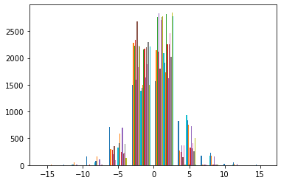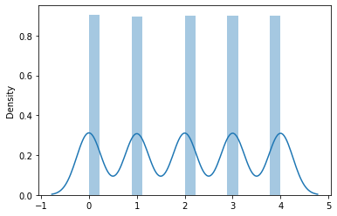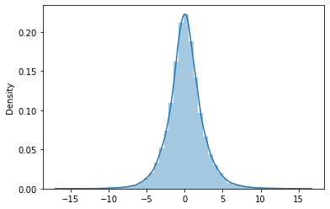

plt

.

hist

(

X

)

plt

.

show

()

sns

.

distplot

(

y

)

plt

.

show

()

sns

.

distplot

(

X

)

plt

.

show

()

feature extraction preprocessing, correlation matrix to check if any pre processing is to be required

In

[4]:

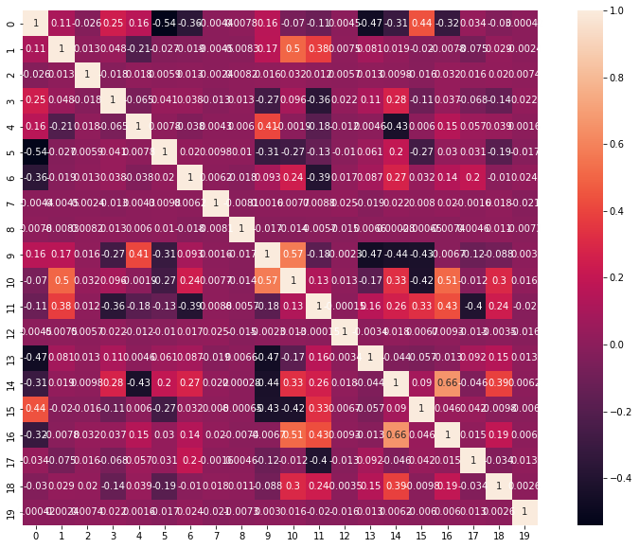

_

,

graph

**=**

plt

.

subplots

(

figsize

**=**

(

15

,

10

))

sns

.

heatmap

(

X

.

corr

()

,

annot

**=**

**True**

,

ax

**=**

graph

,

square

**=**

**True**

)

plt

.

show

()

# Model Building

Random forest classifier creates a set of decision trees from a randomly selected subset of the training set. It is basically a set of decision trees from a randomly selected subset of the training set and then It collects the votes from different decision trees to decide the final prediction. Assuming dataset has “m” features, the random forest will randomly choose “k” features where k < m. Now, the algorithm will calculate the root node among the k features by picking a node that has the highest information gain. After that, the algorithm splits the node into child nodes and repeats this process “n” times. Now we have a forest with n trees. Finally, perform bootstrapping, ie, combine the results of all the decision trees present in the forest.

We have directly used the in built function of sklearn library i.e., from sklearn.ensemble import RandomForestClassifier which directly imports this classifier

# Compile & Train

Firstly splitting the input dataset into training and test parts following which training set is passed through RandomForestClassifier and is fitted to it. and predicting over the test test to check the model performance.

In

[5]:

X_train

,

X_test

,

Y_train

,

Y_test

**=**

train_test_split

(

X

,

y

,

test_size

**=**

0.20

,

random_state

**=**

42

)

model

**=**

RandomForestClassifier

()

model

.

fit

(

X_train

,

Y_train

)

Y_pred

**=**

model

.

predict

(

X_test

)

print

(

"train Accuracy:"

,

model

.

score

(

X_train

,

Y_train

))

print

(

"test Accuracy:"

,

model

.

score

(

X_test

,

Y_test

))

train Accuracy: 1.0 test Accuracy: 0.79

# Result

since training is giving 100% accuracy and in testing it is giving 79% accuracy so it's clearly overfitting so to overcome this we are using k fold cross validation and hyperparameter tuning to improve the overall score and generate generalizesd model and knowing which hyperparameter combination gives best overall score

In [6]: *#Cross Validation without Hyper parameter tuning* **from** sklearn.model_selection **import** KFold **from** sklearn.model_selection **import** cross_val_score clf **=** RandomForestClassifier(max_depth**=**10, random_state**=**0) kf**=**KFold(n_splits**=**7)

score**=**cross_val_score(clf, X, y, scoring**=**'accuracy',cv**=**kf) print("Cross Validation Scores are {}".format(score)) print("Average Cross Validation score :{}".format(score.mean()))

Cross Validation Scores are [0.78461538 0.77062937 0.80672269 0.82633053 0.78431373 0.78011204

0.79411765]

Average Cross Validation score :0.7924059134143168

In [7]: **from** sklearn.model_selection **import** GridSearchCV tuned_parameters **=** [{'n_estimators':[10,20,40,100],'criterion':['gini', 'entropy'], 'max_features':['auto', 'sqrt', 'log2'],'bootstrap':[**True**,**False**]}] clf**=**GridSearchCV(RandomForestClassifier(),tuned_parameters,scoring**=**('accuracy'),verbose**=**3) clf.fit(X,y)

print("Best parameters set found on development set:") print()

print(clf.best_params_) print() print("Best Score:",clf.best_score_)

= 0.3s

[CV 1/5] END bootstrap=False, criterion=gini, max_features=auto, n_estimators=40;, score=0.804 total time

= 0.7s

[CV 2/5] END bootstrap=False, criterion=gini, max_features=auto, n_estimators=40;, score=0.805 total time

= 0.7s

[CV 3/5] END bootstrap=False, criterion=gini, max_features=auto, n_estimators=40;, score=0.813 total time

= 0.7s

[CV 4/5] END bootstrap=False, criterion=gini, max_features=auto, n_estimators=40;, score=0.794 total time

= 0.8s

[CV 5/5] END bootstrap=False, criterion=gini, max_features=auto, n_estimators=40;, score=0.804 total time

= 0.8s

[CV 1/5] END bootstrap=False, criterion=gini, max_features=auto, n_estimators=100;, score=0.810 total tim e= 2.0s

[CV 2/5] END bootstrap=False, criterion=gini, max_features=auto, n_estimators=100;, score=0.827 total tim e= 1.9s

[CV 3/5] END bootstrap=False, criterion=gini, max_features=auto, n_estimators=100;, score=0.837 total tim e= 2.0s

[CV 4/5] END bootstrap=False, criterion=gini, max_features=auto, n_estimators=100;, score=0.805 total tim e= 2.0s

[CV 5/5] END bootstrap=False, criterion=gini, max_features=auto, n_estimators=100;, score=0.821 total tim

2

Best parameters set found on development set:

{'bootstrap': False, 'criterion': 'gini', 'max_features': 'log2', 'n_estimators': 100}

Best Score: 0.8214 Now the overall score is 82.14% accuracy which is above the testing accuracy without cross validation

**Experiment 14**

**DBSCAN Implementation**

**Importing Required Libraries**

In

[1]:

**from**

sklearn

.

cluster

**import**

DBSCAN

**import**

pandas

**as**

pd

**import**

matplotlib

.

pyplot

**as**

plt

**import**

warnings

**from**

sklearn

.

preprocessing

**import**

StandardScaler

warnings

.

filterwarnings

(

'ignore'

)

**Data**

for this experiment we have use make_blobs datsets which are already in sklearn.datasets

sklearn.datasets.make_blobs(n_samples=100, n_features=2, *, centers=None, cluster_std=1.0, center_box=(- 10.0, 10.0), shuffle=True, random_state=None, return_centers=False) Generate isotropic Gaussian blobs for clustering.

In

[2]:

In

[3]:

In

[4]:

Out[4]:

,

2)

(1000

**from**

sklearn

.

datasets

**import**

make_blobs

X

,

y

**=**

make_blobs

(

n_samples

**=**

1000

,

n_features

**=**

2

,

centers

**=**

[[

0.5

,

2

,

[

]

**-**

1

,

**-**

1

]

,

[

1.5

,

**-**

1

]]

,

cluster_std

**=**

0.5

,

center_box

**=**

(

**-**

10.0

,

10.0

)

,

shuffle

**=**

**True**

,

random_state

**=**

42

)

X

.

shape

In [5]: y.shape

Out[5]: (1000,)

**Data Preprocessing and Visualization**

In

[6]:

Out[6]:

149f3388>

<

matplotlib.collections.PathCollection at 0x1bc

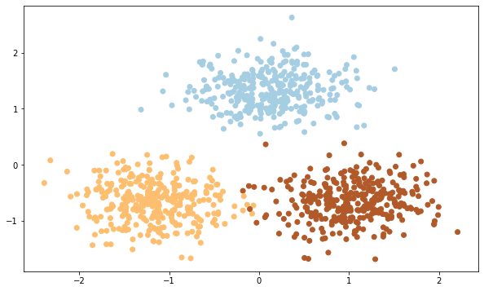

X

**=**

StandardScaler

().

fit_transform

(

X

)

plt

.

figure

(

figsize

**=**

(

10

,

6

))

plt

.

scatter

(

X

,

[:

0

]

,

X

[:

,

1

]

,

c

**=**

y

,

cmap

**=**

'Paired'

)

**Model Building**

In

[7]:

Out[7]:

matplotlib.collections.PathCollection at 0x1bc16dcd

608>

<

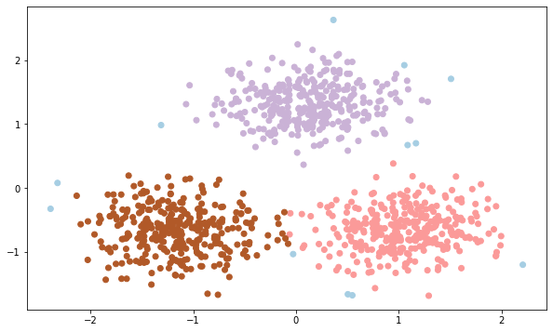

db

**=**

DBSCAN

(

eps

**=**

0.45

,

min_samples

**=**

50

)

db

.

fit

(

X

)

y_pred

**=**

db

.

fit_predict

(

X

)

plt

.

figure

(

figsize

**=**

(

10

,

6

))

plt

.

scatter

(

X

[:

,

0

]

,

X

[:

,

1

]

,

c

**=**

y_pred

,

cmap

**=**

'Paired'

)